**2014**



PROJECT TITLE: Knowledge Planet Library

STUDENT NAME: Myo Thet Tun

STUDENT ID: 018800021524

CLASS CODE: P06Jan14IT204A

LECTURER NAME: Amirrudin Bin Dahlan

SUBJECT: Visual Basic.Net

**TABLE OF CONTENT**

1. **INTRODUCTION** 3
   1. Library’s Background 3
   2. Current System and Problems Background 3
   3. Objectives 5
   4. Requirement Specification of New System 6
      1. Hardware 6
      2. Software 6
2. **DESIGN** 7
   1. Structure Chart 7
   2. Input Screen Layouts 8
   3. Output Screen Layouts 16
3. **PROGRAM LISTING** 21
4. **TESTING** 68
   1. Test Plan 68
   2. Test Cases 69
   3. Test Results 93
5. **OPERATING INSTRUCTION** 94
   1. Using the System 94
6. **CONCLUSION** 100
   1. Program Strengths 100
   2. Program Weaknesses 100
   3. Program Enhancement 101
7. **REFERENCES** 102
8. **INTRODUCTION**

**1.1 library’s background**

Knowledge Planet Library is a library of “Knowledge Planet Academy”, a private learning center founded in the year 2004 and is located in Yangon, Myanmar. The library was officially opened in the year 2005 for the purpose of getting more references, knowledge and information for the students of this school. The library was rather a small one when it was founded. Now, over the past 9 years, the size of the library is getting bigger because the library’s officials have been buying many new kinds of books to become a better library and the students’ knowledge center point.

**1.2 current system and problem background**

Since the library was founded, the staffs have been doing all the works manually. That is, the librarians have to record everyday transactions manually on the paper- based system. He or she has to write down every detail in the books daily. It’s really a time consuming and data inconsistency is also very high. Below are the problems that current system is facing with.

**Slow Retrieval of Data** - The information is stored in different parts of the site and it may take a long time to retrieve or update the data. Sometimes, it can take up to 15 or 20 minutes finding the relevant information.

**Paper Wastage** - Much paper is waste due to the number of records daily and number of library members. Duplication of data can be occurred by repeating the same thing over and over.

**Unproductive use of storage space** - Paper takes up a massive amount of room in the site.

**Poor Customer Service** - Sometimes, the information may be unavailable.

**No reliable database system** - The records on paper can be lost or damaged at any time. Since there is no backup for the data, the lost or damaged documents cannot be regained at all.

**No security system** – Writing on paper is totally lack of security system. Any unauthorized person may see, update or even the data can be stolen.

These are the weak points that the current system is facing with.

**1.3 objectives**

The main purpose of the new system is to handle all the problems that the old system is currently facing with. With the newly implemented system, the records can be easily created. There will be no duplication of data records because all the data records are controlled by a primary key called ID. There is also an error checking method to detect the data type error (e.g. the record cannot be stored when user types the alphabet character for the maximum loan items, a numeric value must be typed in). For retrieval of the records, it is much faster and easier than the previous system. Editing and deleting also can be easily and quickly performed. The records are to be stored in the security enabled database system which can store many lines of data records. There will be no store room at all to store the documents and no paper wastage at all. So, all the current problems will be solved with this single “Library Management System”. The staff will only need to sit at the workstation just to perform all these tasks.

These are the advantages of the new “Library Management System”.

* 1. **requirement specifications of new system**

For best performance, these are the requirements for the system:

**1.4.1 hardware**

Intel(R) Core™ i5 3230M CPU @ 2.60 GHz

3GB RAM or higher

20GB of HDD

USB Hub

LED Monitor with Standard Keyboard and Mouse

**1.4.2 software**

Windows 7 OS

Microsoft Access 2007

Microsoft Visual Studio.Net 2010

1. **DESIGN**

**2.1 structure chart**

**MEMBER INFORMATION**

**PUBLISHER INFORMATION**

**CATEGORY INFORMATION**

**BOOK INFORMATION**

**RENTAL INFORMATION**

**MAIN PAGE**

**2.2 input screen layouts**

**frm_main.vb**

mnu_file

**lbl_library_name**

**lbl_library**

|  |  |  |  |
| --- | --- | --- | --- |
| **Field** | **Description** | **Type** | **Name (ID)** |
| MenuStrip1 | File | Menu Bar | mnu_file |
| Label1 | Knowledge Planet | Label | lbl_library_name |
| Label2 | Library Management System | Label | lbl_library |

frm_member.vb

**btn_update**

**btn_add**

**lbl_mem_id**

**txt_mem_name**

**txt_mem_id**

**lbl_mem_name**

gb_member

**btn_delete**

**btn_show_all**

**lbl_phone**

**txt_phone**

**dt_reg_date**

**lbl_reg_date**

**lbl_ic**

**txt_ic**

**txt_addr**

**lbl_addr**

**lbl_max_items**

**lbl_exp_date**

**txt_max_items**

**dt_exp_date**

**btn_cancel**

**btn_save**

**dg_member**

**btn_back_to_main**

|  |  |  |  |
| --- | --- | --- | --- |
| **Field** | **Description** | **Type** | **Name (ID)** |
| Group Box1 | Group-Member Information | group box | gb_member |
| Label1 | Label - Member ID | label | lbl_mem_id |
| Label2 | Label - Member Name | Label | lbl_mem_name |
| Label3 | Label - IC No: | label | lbl_ic |
| Label4 | Label - Address | label | lbl_addr |
| Label5 | Label - Phone | label | lbl_phone |
| Label6 | Label - Registration Date | label | lbl_reg_date |
| Label7 | Label - Expiry Date | label | lbl_exp_date |
| Label8 | Label - Maximum Items | label | lbl_max_items |
| Text Box1 | Insert – Member ID | Text | txt_mem_id |
| Text Box2 | Insert – Member Name | Text | txt_mem_name |
| Text Box3 | Insert – IC No: | Text | txt_ic |
| Text Box4 | Insert – Address | Text | txt_addr |
| Text Box5 | Insert – Phone | Text | txt_phone |
| dt_Picker1 | Insert – Registration Date | date time Picker | dt_reg_date |
| dt_Picker2 | Insert – Expiry Date | date time Picker | dt_exp_date |
| Text Box6 | Insert – Maximum Items | Text | txt_max_items |
| Data Grid1 | Display all the data | Data Grid | dg_member |
| Button1 | To add record | Command Button | btn_add |
| Button2 | To update record | Command Button | btn_update |
| Button3 | To delete record | Command Button | btn_delete |
| Button4 | To save changes | Command Button | btn_save |
| Button5 | To cancel action | Command Button | btn_cancel |
| Button6 | To show all data in grid | Command Button | btn_show_all |
| Button7 | To go back to main form | Command Button | btn_back_to_main |

frm_book.vb

**btn_cancel**

**btn_save**

**btn_back_to_main**

**btn_delete**

**btn_update**

**btn_show_all**

**btn_add**

**txt_price**

**txt_isbn**

**lbl_price**

**lbl_isbn**

**lbl_pub_id**

**cbo_pub_id**

**cbo_cat_id**

**lbl_cat_id**

**lbl_desc**

**txt_desp**

**txt_author**

**lbl_author**

**lbl_title**

**txt_title**

**txt_b_id**

gb_book

**lbl_b_id**

**dt_pdate**

**lbl_pdate**

**dg_book**

|  |  |  |  |
| --- | --- | --- | --- |
| **Field** | **Description** | **Type** | **Name (ID)** |
| Group Box1 | Group - Book Information | group box | gb_book |
| Label1 | Label - Book ID | label | lbl_b_id |
| Label2 | Label - Title | Label | lbl_title |
| Label3 | Label - Author’s Name | label | lbl_author |
| Label4 | Label – Description | label | lbl_desc |
| Label5 | Label - Category ID | label | lbl_cat_id |
| Label6 | Label – Publisher ID | label | lbl_pub_id |
| Label7 | Label – ISBN | label | lbl_isbn |
| Label8 | Label - Purchasing Price | label | lbl_price |
| Label9 | Label – Purchasing Date | label | lbl_pdate |
| Text Box1 | Insert – Book ID | Text | txt_b_id |
| Text Box2 | Insert – Title | Text | txt_title |
| Text Box3 | Insert – Author’s Name | Text | txt_author |
| Text Box4 | Insert – Description | Text | txt_desp |
| Combo Box1 | Insert – Category ID | Combo Box | cbo_cat_id |
| Combo Box2 | Insert – Publisher ID | Combo Box | cbo_pub_id |
| Text Box5 | Insert – ISBN | Text | txt_isbn |
| Text Box6 | Insert – Purchasing Price | Text | txt_price |
| dt_Picker1 | Insert – Purchasing Date | Date time Picker | dt_pdate |
| Data Grid1 | Display all the data | Data Grid | dg_book |
| Button1 | To add record | Command Button | btn_add |
| Button2 | To update record | Command Button | btn_update |
| Button3 | To delete record | Command Button | btn_delete |
| Button4 | To save changes | Command Button | btn_save |
| Button5 | To cancel action | Command Button | btn_cancel |
| Button6 | To show all data in grid | Command Button | btn_show_all |
| Button7 | To go back to main form | Command Button | btn_back_to_main |

frm_category.vb

gb_category

**btn_add**

**btn_show_all**

**btn_update**

**btn_delete**

**btn_save**

**btn_cancel**

**lbl_cat_name**

**txt_cat_name**

**txt_cat_id**

**lbl_cat_id**

**btn_back_to_main**

**dg_category**

|  |  |  |  |
| --- | --- | --- | --- |
| **Field** | **Description** | **Type** | **Name (ID)** |
| Group Box1 | Group - Category Information | group box | gb_category |
| Label1 | Label – Category ID | label | lbl_cat_id |
| Label2 | Label - Category Name | Label | lbl_cat_name |
| Text Box1 | Insert – Category ID | Text | txt_cat_id |
| Text Box2 | Insert – Category Name | Text | txt_cat_name |
| Data Grid1 | Display all the data | Data Grid | dg_category |
| Button1 | To add record | Command Button | btn_add |
| Button2 | To update record | Command Button | btn_update |
| Button3 | To delete record | Command Button | btn_delete |
| Button4 | To save changes | Command Button | btn_save |
| Button5 | To cancel action | Command Button | btn_cancel |
| Button6 | To show all data in grid | Command Button | btn_show_all |
| Button7 | To go back to main form | Command Button | btn_back_to_main |

frm_publisher.vb

gb_publisher

**btn_cancel**

**btn_save**

**btn_back_to_main**

**dg_publisher**

**btn_delete**

**btn_update**

**btn_show_all**

**btn_add**

**lbl_pub_name**

**txt_pub_name**

**txt_pub_id**

**lbl_pub_id**

|  |  |  |  |
| --- | --- | --- | --- |
| **Field** | **Description** | **Type** | **Name (ID)** |
| Group Box1 | Group - Category Information | group box | gb_publisher |
| Label1 | Label – Publisher ID | label | lbl_pub_id |
| Label2 | Label – Publisher Name | Label | lbl_ pub _name |
| Text Box1 | Insert – Publisher ID | Text | txt_ pub _id |
| Text Box2 | Insert – Publisher Name | Text | txt_ pub _name |
| Data Grid1 | Display all the data | Data Grid | dg_publisher |
| Button1 | To add record | Command Button | btn_add |
| Button2 | To update record | Command Button | btn_update |
| Button3 | To delete record | Command Button | btn_delete |
| Button4 | To save changes | Command Button | btn_save |
| Button5 | To cancel action | Command Button | btn_cancel |
| Button6 | To show all data in grid | Command Button | btn_show_all |
| Button7 | To go back to main form | Command Button | btn_back_to_main |

frm_transaction.vb

**lbl_tran_id**

gb_tran

**txt_tran_id**

**cbo_mem_id**

**lbl_mem_id**

**lbl_b_id**

**cbo_b_id**

**dt_borrow_date**

**lbl_borrow_date**

**lbl_due_date**

**dt_due_date**

**cbo_status**

**lbl_status**

**btn_add**

**btn_show_all**

**btn_update**

**btn_delete**

**btn_save**

**btn_cancel**

**dg_tran**

**btn_back_to_main**

|  |  |  |  |
| --- | --- | --- | --- |
| **Field** | **Description** | **Type** | **Name (ID)** |
| Group Box1 | Group - Book Information | group box | gb_tran |
| Label1 | Label - Transaction ID | label | lbl_tran_id |
| Label2 | Label – Member ID | Label | lbl_mem_id |
| Label3 | Label – Book ID | label | lbl_b_id |
| Label4 | Label – Borrow Date | label | lbl_borrow_date |
| Label5 | Label – Due Date | label | lbl_due_date |
| Label6 | Label – Status | label | lbl_status |
| Text Box1 | Insert – Transaction ID | Text | txt_ tran_id |
| Combo Box1 | Insert – Member ID | Combo Box | cbo_ mem_id |
| Combo Box2 | Insert – Book ID | Combo Box | cbo_ b_id |
| dt_Picker1 | Insert – Borrow Date | Date time Picker | dt_ borrow_date |
| dt_Picker1 | Insert – Due Date | Date time Picker | dt_ due_date |
| Combo Box2 | Insert – Status | Combo Box | cbo_ status |
| Data Grid1 | Display all the data | Data Grid | dg_ tran |
| Button1 | To add record | Command Button | btn_add |
| Button2 | To update record | Command Button | btn_update |
| Button3 | To delete record | Command Button | btn_delete |
| Button4 | To save changes | Command Button | btn_save |
| Button5 | To cancel action | Command Button | btn_cancel |
| Button6 | To show all data in grid | Command Button | btn_show_all |
| Button7 | To go back to main form | Command Button | btn_back_to_main |

**2.3 output screen layouts**

frm_main.vb



frm_member.vb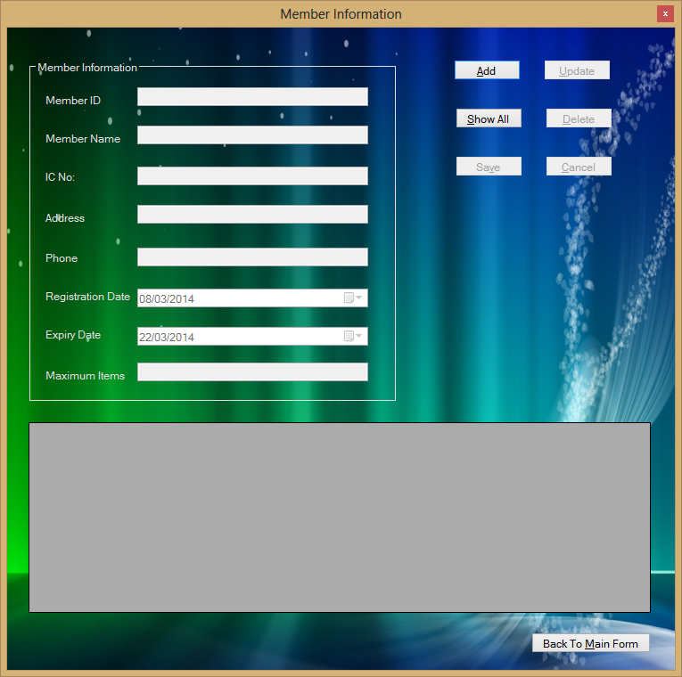

frm_book.vb

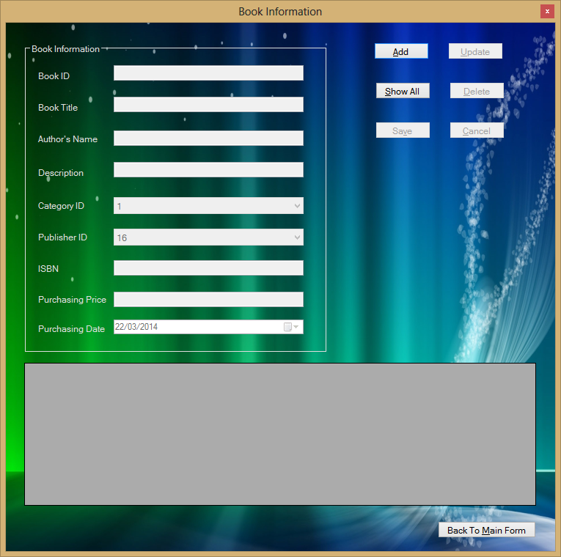

frm_category.vb

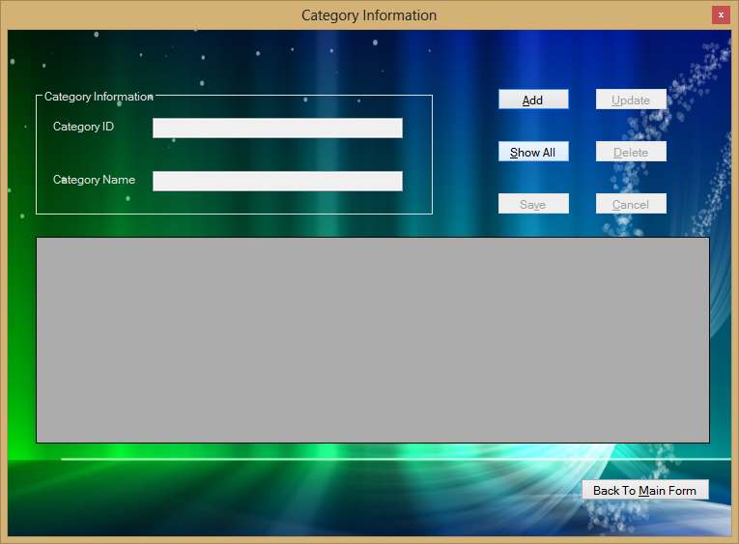

frm_publisher.vb

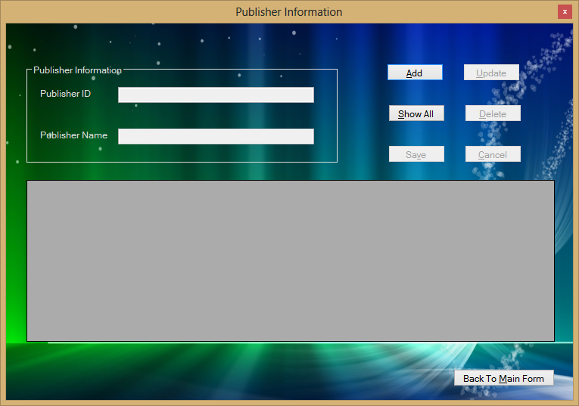

frm_transaction.vb

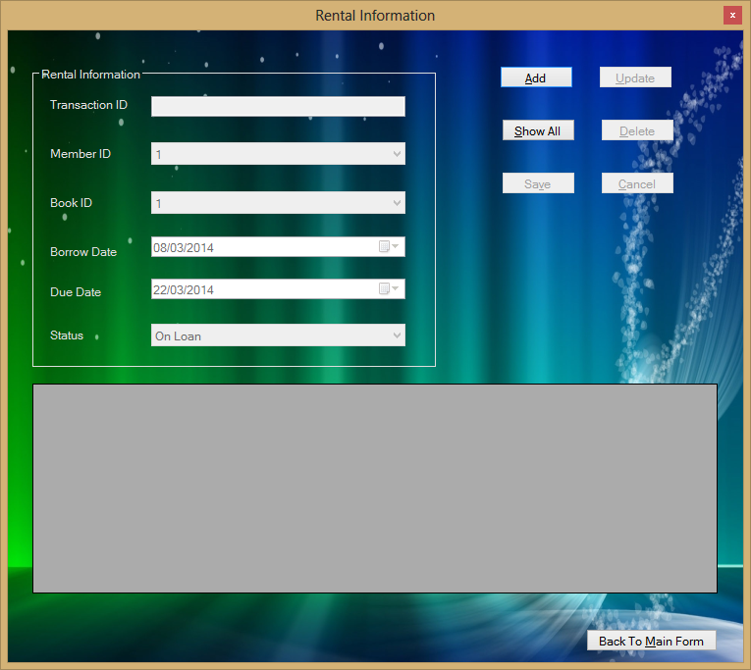

1. **PROGRAM LISTING**

**frm_main.vb**

Public Class frm_main

Private Sub frm_main_Load(sender As Object, e As EventArgs) Handles MyBase.Load

'start the form as maximized state

Me.WindowState = FormWindowState.Maximized

'add background image for form

Me.BackgroundImage = Image.FromFile("D:\My Projects\Library Management\Wallpaper.jpg")

End Sub

Private Sub mnu_exit_Click(sender As Object, e As EventArgs) Handles mnu_exit.Click

'exit from the whole application

Application.Exit()

End Sub

Private Sub mnu_publisher_Click(sender As Object, e As EventArgs) Handles mnu_publisher.Click

'hide current from and show publisher form

Me.Hide()

frm_publisher.Show()

End Sub

Private Sub mnu_category_Click(sender As Object, e As EventArgs) Handles mnu_category.Click

'hide current from and show category form

Me.Hide()

frm_category.Show()

End Sub

Private Sub mnu_member_Click(sender As Object, e As EventArgs) Handles mnu_member.Click

'hide current from and show member form

Me.Hide()

frm_member.Show()

End Sub

Private Sub mnu_book_Click(sender As Object, e As EventArgs) Handles mnu_book.Click

'hide current from and show book form

Me.Hide()

frm_book.Show()

End Sub

Private Sub mnu_rental_Click(sender As Object, e As EventArgs) Handles mnu_rental.Click

'hide current form and show transaction form

Me.Hide()

frm_transaction.Show()

End Sub

End Class

**frm_member.vb**

Imports System

Imports System.Data

Imports System.Data.OleDb

Public Class frm_member

'define path to database

Public dsn_name As String = "Provider=Microsoft.ACE.OLEDB.12.0;Data Source= D:\\My Projects\\" & _

"Library Management\\library.accdb"

'initialize variable

Dim add_edit As String = ""

Dim msg_title As String = "Library Management System"

Private Sub btn_switch(ByVal func As Boolean)

'boolean sub routine for buttons enable and disable

btn_add.Enabled = func

btn_show_all.Enabled = func

btn_back_to_main.Enabled = func

End Sub

Private Sub btn_save_cancel(ByVal func As Boolean)

'boolean sub routine for buttons enable and disable

btn_save.Enabled = func

btn_cancel.Enabled = func

End Sub

Private Sub btn_delete_update(ByVal func As Boolean)

'boolean sub routine for buttons enable and disable

btn_delete.Enabled = func

btn_update.Enabled = func

End Sub

Private Sub clear_textbox()

'clear text boxes and reset

txt_mem_name.Text = ""

txt_ic.Text = ""

txt_addr.Text = ""

txt_phone.Text = ""

dt_reg_date.ResetText()

dt_exp_date.ResetText()

txt_max_items.Text = ""

End Sub

Private Sub txt_read_only(ByVal func As Boolean)

'make other text box(es) read only

txt_mem_name.ReadOnly = func

txt_ic.ReadOnly = func

txt_addr.ReadOnly = func

txt_phone.ReadOnly = func

dt_reg_date.Enabled = Not (func)

dt_exp_date.Enabled = Not (func)

txt_max_items.ReadOnly = func

End Sub

Private Sub assign_data_show_values()

'assign data grid's values to variables

Dim mem_id As String = dg_member.SelectedRows(0).Cells(0).Value.ToString()

Dim mem_name As String = dg_member.SelectedRows(0).Cells(1).Value.ToString()

Dim ic As String = dg_member.SelectedRows(0).Cells(2).Value.ToString()

Dim addr As String = dg_member.SelectedRows(0).Cells(3).Value.ToString()

Dim phone As String = dg_member.SelectedRows(0).Cells(4).Value.ToString()

Dim reg_date As String = dg_member.SelectedRows(0).Cells(5).Value.ToString()

Dim exp_date As String = dg_member.SelectedRows(0).Cells(6).Value.ToString()

Dim max_items As String = dg_member.SelectedRows(0).Cells(7).Value.ToString()

'show values in text boxes

txt_mem_id.Text = mem_id

txt_mem_name.Text = mem_name

txt_ic.Text = ic

txt_addr.Text = addr

txt_phone.Text = phone

dt_reg_date.Value = reg_date

dt_exp_date.Value = exp_date

txt_max_items.Text = max_items

End Sub

Private Sub btn_back_to_main_Click(sender As Object, e As EventArgs) Handles btn_back_to_main.Click

'hide current form and show main form

Me.Hide()

frm_main.Show()

End Sub

Private Sub btn_show_all_Click(sender As Object, e As EventArgs) Handles btn_show_all.Click

'create the database connection

Dim cn As New OleDbConnection(dsn_name)

'create the select SQL

Dim da As New OleDbDataAdapter("SELECT mem_id AS [Member ID],mem_name AS [Member Name],ic AS [IC No]," & _

"addr AS [Address],phone AS [Phone],reg_date AS [Registration Date]," & _

"exp_date AS [Expiry Date],max_items AS [Maximum Items] FROM member " & _

"ORDER BY mem_id", cn)

Dim dt As New DataTable

da.Fill(dt)

da.Dispose()

cn.Dispose()

dg_member.DataSource = dt

'enable and disable of buttons

btn_save_cancel(False)

btn_switch(True)

btn_delete_update(True)

'make other text box(es) read only

txt_read_only(True)

End Sub

Private Sub frm_member_FormClosed(sender As Object, e As FormClosedEventArgs) Handles Me.FormClosed

'show the main form if the user close current form

frm_main.Show()

End Sub

Private Sub frm_member_Load(sender As Object, e As EventArgs) Handles MyBase.Load

'hide the maximize and minimize buttons

Me.FormBorderStyle = Windows.Forms.FormBorderStyle.FixedToolWindow

'add background image for form

Me.BackgroundImage = Image.FromFile("D:\My Projects\Library Management\Wallpaper.jpg")

'make the ID text box read only

Me.txt_mem_id.ReadOnly = True

'make the data grid read only

Me.dg_member.ReadOnly = True

'maximum number of loan items should be 2 digit number only

txt_max_items.MaxLength = 2

'enable and disable of buttons

btn_save_cancel(False)

btn_switch(True)

btn_delete_update(False)

'make other text box(es) read only

txt_read_only(True)

End Sub

Private Sub btn_add_Click(sender As Object, e As EventArgs) Handles btn_add.Click

'show "Auto Number" to user as this text box is a read only text box

txt_mem_id.Text = "Auto Number"

'clear text box(es) and reset date

clear_textbox()

'make other text box(es) can type

txt_read_only(False)

'set focus to text box

txt_mem_name.Focus()

'assign value to add_edit

add_edit = "add"

'enable and disable of buttons

btn_switch(False)

btn_save_cancel(True)

btn_delete_update(False)

End Sub

Private Sub btn_save_Click(sender As Object, e As EventArgs) Handles btn_save.Click

'check validation to text boxes

If validate_fields() = True Then

'if the variable contains 'add'

If add_edit = "add" Then

'get data from text box(es)

Dim mem_name As String = Trim(txt_mem_name.Text)

Dim ic As String = Trim(txt_ic.Text)

Dim addr As String = Trim(txt_addr.Text)

Dim phone As String = Trim(txt_phone.Text)

Dim reg_date As String = dt_reg_date.Value.ToString("dd/MM/yyyy")

Dim exp_date As String = dt_exp_date.Value.ToString("dd/MM/yyyy")

Dim max_items As String = Trim(txt_max_items.Text)

'insert a record to the table

Dim str_add As String = "INSERT INTO member (mem_name,ic,addr,phone,reg_date,exp_date,max_items) " & _

"VALUES ('" & mem_name & "','" & ic & "','" & addr & "','" & phone & "',#" & _

reg_date & "#,#" & exp_date & "#," & max_items & ")"

'create database connection

Dim cn As New OleDbConnection(dsn_name)

Dim cmd As New OleDbCommand

With cmd

.CommandText = str_add

.Connection = cn

.Connection.Open()

.ExecuteNonQuery()

.Connection.Close()

.Dispose()

End With

cn.Dispose()

'show status

MessageBox.Show("The record is added !", msg_title, MessageBoxButtons.OK, MessageBoxIcon.Information)

'refresh data grid

btn_show_all_Click(btn_show_all, New EventArgs())

'if the variable contains 'edit'

Else

'get data from text boxes

Dim mem_id As String = txt_mem_id.Text

Dim mem_name As String = Trim(txt_mem_name.Text)

Dim ic As String = Trim(txt_ic.Text)

Dim addr As String = Trim(txt_addr.Text)

Dim phone As String = Trim(txt_phone.Text)

Dim reg_date As String = dt_reg_date.Value.ToString("dd/MM/yyyy")

Dim exp_date As String = dt_exp_date.Value.ToString("dd/MM/yyyy")

Dim max_items As String = Trim(txt_max_items.Text)

'update record according to specific ID

Dim str_update As String = "UPDATE member SET mem_name = '" & mem_name & "', ic = '" & ic & _

"', addr = '" & addr & "', phone = '" & phone & "', reg_date = #" & _

reg_date & "#, exp_date= #" & exp_date & "#, max_items= " & max_items & _

" WHERE mem_id = " & mem_id

'create database connection

Dim cn As New OleDbConnection(dsn_name)

Dim cmd As New OleDbCommand

With cmd

.CommandText = str_update

.Connection = cn

.Connection.Open()

.ExecuteNonQuery()

.Connection.Close()

.Dispose()

End With

cn.Dispose()

'show status

MessageBox.Show("The record is updated !", msg_title, MessageBoxButtons.OK, MessageBoxIcon.Information)

'refresh data grid

btn_show_all_Click(btn_show_all, New EventArgs())

End If

Else

'if the data is not validated then exit this sub routine

Exit Sub

End If

'enable and disable of buttons

btn_save_cancel(False)

btn_switch(True)

btn_delete_update(False)

'make other text box(es) read only

txt_read_only(True)

'set variable to null

add_edit = ""

End Sub

Private Function validate_fields() As Boolean

'check validation of data entries

If Trim(txt_mem_name.Text) = "" Then

'if the data fields are empty

MessageBox.Show("Name cannot be empty !", msg_title, MessageBoxButtons.OK, MessageBoxIcon.Error)

'make other text box(es) can type

txt_read_only(False)

txt_mem_name.Focus()

Return False

End If

If Trim(txt_ic.Text) = "" Then

MessageBox.Show("IC number cannot be empty !", msg_title, MessageBoxButtons.OK, MessageBoxIcon.Error)

'make other text box(es) can type

txt_read_only(False)

txt_ic.Focus()

Return False

End If

If Trim(txt_addr.Text) = "" Then

MessageBox.Show("Address cannot be empty !", msg_title, MessageBoxButtons.OK, MessageBoxIcon.Error)

'make other text box(es) can type

txt_read_only(False)

txt_addr.Focus()

Return False

End If

If Trim(txt_phone.Text) = "" Then

MessageBox.Show("Phone cannot be empty !", msg_title, MessageBoxButtons.OK, MessageBoxIcon.Error)

'make other text box(es) can type

txt_read_only(False)

txt_mem_name.Focus()

Return False

End If

If Trim(txt_max_items.Text) = "" Then

MessageBox.Show("Maximum items cannot be empty", msg_title, MessageBoxButtons.OK, MessageBoxIcon.Error)

'make other text box(es) can type

txt_read_only(False)

txt_max_items.Focus()

Return False

End If

Try

Dim valid_max_items As Integer = CInt(txt_max_items.Text)

Catch ex As Exception

'if it's not a valid number format

MessageBox.Show("Please enter a valid number !", msg_title, MessageBoxButtons.OK, MessageBoxIcon.Error)

'make other text box(es) can type

txt_read_only(False)

txt_max_items.Focus()

Return False

End Try

Return True

End Function

Private Sub btn_update_Click(sender As Object, e As EventArgs) Handles btn_update.Click

Try

Dim selected_row_count As Integer = dg_member.Rows.GetRowCount(DataGridViewElementStates.Selected)

If selected_row_count > 0 Then

'assign data grid's values to variables and show values in text boxes

assign_data_show_values()

End If

'user choose a blank row in data grid view to perform operation

Catch ex As Exception

MessageBox.Show("Error !!!" & vbNewLine & _

"Choose a valid record !", msg_title, MessageBoxButtons.OK, MessageBoxIcon.Error)

'make other text box(es) read only

txt_read_only(True)

'enable and disable of buttons

btn_save_cancel(False)

btn_switch(True)

btn_delete_update(True)

'exit this sub routine

Exit Sub

End Try

'make other text box(es) can type

txt_read_only(False)

txt_mem_name.Focus()

'assign 'edit' in variable

add_edit = "edit"

'enable and disable of buttons

btn_save_cancel(True)

btn_switch(False)

btn_delete_update(False)

End Sub

Private Sub btn_cancel_Click(sender As Object, e As EventArgs) Handles btn_cancel.Click

'clear text boxes

txt_mem_id.Text = ""

clear_textbox()

'buttons enable and disable

btn_save_cancel(False)

btn_switch(True)

btn_delete_update(False)

'make other text box(es) read only

txt_read_only(True)

End Sub

Private Sub btn_delete_Click(sender As Object, e As EventArgs) Handles btn_delete.Click

Dim selected_row_count As Integer = dg_member.Rows.GetRowCount(DataGridViewElementStates.Selected)

'if there is no row in table

If selected_row_count = 0 Then

'show status

MessageBox.Show("No records to delete !", msg_title, MessageBoxButtons.OK, MessageBoxIcon.Exclamation)

'enable and disable of buttons

btn_save_cancel(False)

btn_switch(True)

btn_delete_update(False)

'make other text box(es) read only

txt_read_only(True)

'exit this sub routine

Exit Sub

End If

Try

'if there is at least one record

If selected_row_count > 0 Then

'assign data and show values in text boxes

assign_data_show_values()

End If

'user choose a blank row in data grid view to perform operation

Catch ex As Exception

MessageBox.Show("Error !!!" & vbNewLine & _

"Choose a valid record !", msg_title, MessageBoxButtons.OK, MessageBoxIcon.Error)

'make other text box(es) read only

txt_read_only(True)

'enable and disable of buttons

btn_save_cancel(False)

btn_switch(True)

btn_delete_update(True)

'exit this sub routine

Exit Sub

End Try

'ask confirmation to delete

If (MessageBox.Show("Are you sure you want to delete " & _

"this record ?", msg_title, MessageBoxButtons.YesNo, MessageBoxIcon.Question) = vbYes) Then

Dim mem_id As String = txt_mem_id.Text

'create database connection

Dim cn As New OleDbConnection(dsn_name)

Dim cmd As New OleDbCommand

With cmd

'delete the specific record according to ID

.CommandText = "DELETE FROM member WHERE mem_id = " & mem_id

.Connection = cn

.Connection.Open()

.ExecuteNonQuery()

.Connection.Close()

.Dispose()

End With

cn.Dispose()

'show status

MessageBox.Show("The record is deleted !", msg_title, MessageBoxButtons.OK, MessageBoxIcon.Exclamation)

'clear text box(es)

txt_mem_id.Text = ""

clear_textbox()

'refresh data grid

btn_show_all_Click(btn_show_all, New EventArgs())

Else

MessageBox.Show("The record is not deleted !", msg_title, MessageBoxButtons.OK, MessageBoxIcon.Information)

End If

'enable and disable of buttons

btn_save_cancel(False)

btn_switch(True)

btn_delete_update(False)

'make other text box(es) read only

txt_read_only(True)

End Sub

End Class

**frm_book.vb**

Imports System

Imports System.Data

Imports System.Data.OleDb

Public Class frm_book

'define path to database

Public dsn_name As String = "Provider=Microsoft.ACE.OLEDB.12.0;Data Source= D:\\My Projects\\" & _

"Library Management\\library.accdb"

'initialize variable

Dim add_edit As String = ""

Dim msg_title As String = "Library Management System"

Private Sub btn_switch(ByVal func As Boolean)

'boolean sub routine for buttons enable and disable

btn_add.Enabled = func

btn_show_all.Enabled = func

btn_back_to_main.Enabled = func

End Sub

Private Sub btn_save_cancel(ByVal func As Boolean)

'boolean sub routine for buttons enable and disable

btn_save.Enabled = func

btn_cancel.Enabled = func

End Sub

Private Sub btn_delete_update(ByVal func As Boolean)

'boolean sub routine for buttons enable and disable

btn_delete.Enabled = func

btn_update.Enabled = func

End Sub

Private Sub clear_textbox()

'clear text boxes and reset

txt_title.Text = ""

txt_author.Text = ""

txt_desp.Text = ""

txt_isbn.Text = ""

txt_price.Text = ""

dt_pdate.ResetText()

End Sub

Private Sub txt_read_only(ByVal func As Boolean)

'make other text box(es) read only

txt_title.ReadOnly = func

txt_author.ReadOnly = func

txt_desp.ReadOnly = func

cbo_cat_id.Enabled = Not (func)

cbo_pub_id.Enabled = Not (func)

txt_isbn.ReadOnly = func

txt_price.ReadOnly = func

dt_pdate.Enabled = Not (func)

End Sub

Private Sub assign_data_show_values()

'assign data grid's values to variables

Dim b_id As String = dg_book.SelectedRows(0).Cells(0).Value.ToString()

Dim title As String = dg_book.SelectedRows(0).Cells(1).Value.ToString()

Dim author As String = dg_book.SelectedRows(0).Cells(2).Value.ToString()

Dim desp As String = dg_book.SelectedRows(0).Cells(3).Value.ToString()

Dim cat_id As String = dg_book.SelectedRows(0).Cells(4).Value.ToString()

Dim pub_id As String = dg_book.SelectedRows(0).Cells(5).Value.ToString()

Dim isbn As String = dg_book.SelectedRows(0).Cells(6).Value.ToString()

Dim price As String = dg_book.SelectedRows(0).Cells(7).Value.ToString()

Dim pdate As String = dg_book.SelectedRows(0).Cells(8).Value.ToString()

'show values in text boxes

txt_b_id.Text = b_id

txt_title.Text = title

txt_author.Text = author

txt_desp.Text = desp

cbo_cat_id.Text = cat_id

cbo_pub_id.Text = pub_id

txt_isbn.Text = isbn

txt_price.Text = price

dt_pdate.Value = pdate

End Sub

Private Function validate_fields() As Boolean

'check validation of data entries

If Trim(txt_title.Text) = "" Then

'if the data fields are empty

MessageBox.Show("Book title cannot be empty !", msg_title, MessageBoxButtons.OK, MessageBoxIcon.Error)

'make other text box(es) can type

txt_read_only(False)

txt_title.Focus()

Return False

End If

If Trim(txt_author.Text) = "" Then

MessageBox.Show("Author cannot be empty !", msg_title, MessageBoxButtons.OK, MessageBoxIcon.Error)

'make other text box(es) can type

txt_read_only(False)

txt_author.Focus()

Return False

End If

If Trim(txt_desp.Text) = "" Then

MessageBox.Show("Description cannot be empty !", msg_title, MessageBoxButtons.OK, MessageBoxIcon.Error)

'make other text box(es) can type

txt_read_only(False)

txt_desp.Focus()

Return False

End If

If Trim(txt_isbn.Text) = "" Then

MessageBox.Show("ISBN cannot be empty !", msg_title, MessageBoxButtons.OK, MessageBoxIcon.Error)

'make other text box(es) can type

txt_read_only(False)

txt_isbn.Focus()

Return False

End If

If Trim(txt_price.Text) = "" Then

MessageBox.Show("Price cannot be empty", msg_title, MessageBoxButtons.OK, MessageBoxIcon.Error)

'make other text box(es) can type

txt_read_only(False)

txt_price.Focus()

Return False

End If

Try

Dim valid_price As Decimal = CDec(txt_price.Text)

Catch ex As Exception

'if it's not a valid number format

MessageBox.Show("Please enter a valid price !", msg_title, MessageBoxButtons.OK, MessageBoxIcon.Error)

'make other text box(es) can type

txt_read_only(False)

txt_price.Focus()

Return False

End Try

Return True

End Function

Private Sub btn_back_to_main_Click(sender As Object, e As EventArgs) Handles btn_back_to_main.Click

'hide current form and show main form

Me.Hide()

frm_main.Show()

End Sub

Private Sub btn_show_all_Click(sender As Object, e As EventArgs) Handles btn_show_all.Click

'create the database connection

Dim cn As New OleDbConnection(dsn_name)

'create the select SQL

Dim da As New OleDbDataAdapter("SELECT b_id AS [Book ID],title AS Title,author AS Author," & _

"desp AS Description,cat_id AS [Category ID],pub_id AS [Publisher ID]," & _

"isbn AS [ISBN No],price AS [Purchasing Price],pdate AS [Purchasing Date]" & _

" FROM book ORDER BY b_id", cn)

Dim dt As New DataTable

da.Fill(dt)

da.Dispose()

cn.Dispose()

dg_book.DataSource = dt

'enable and disable of buttons

btn_save_cancel(False)

btn_switch(True)

btn_delete_update(True)

'make other text box(es) read only

txt_read_only(True)

End Sub

Private Sub frm_member_FormClosed(sender As Object, e As FormClosedEventArgs) Handles Me.FormClosed

'show the main form if the user close current form

frm_main.Show()

End Sub

Private Sub frm_book_Load(sender As Object, e As EventArgs) Handles Me.Load

'hide the maximize and minimize buttons

Me.FormBorderStyle = Windows.Forms.FormBorderStyle.FixedToolWindow

'add background image for form

Me.BackgroundImage = Image.FromFile("D:\My Projects\Library Management\Wallpaper.jpg")

'make the ID text box read only

Me.txt_b_id.ReadOnly = True

'make the data grid read only

Me.dg_book.ReadOnly = True

'to take category ID from category table

'create the database connection

Dim cn As New OleDbConnection(dsn_name)

'create the select SQL

Dim da_cat As New OleDbDataAdapter("SELECT cat_id FROM category ORDER BY cat_id", cn)

Dim dt_cat As New DataTable

da_cat.Fill(dt_cat)

da_cat.Dispose()

cn.Dispose()

cbo_cat_id.DataSource = dt_cat

cbo_cat_id.DisplayMember = "cat_id"

'to take publisher ID from publisher table

'create the database connection

Dim con As New OleDbConnection(dsn_name)

'create the select SQL

Dim dat As New OleDbDataAdapter("SELECT pub_id FROM publisher ORDER BY pub_id", con)

Dim tab As New DataTable

dat.Fill(tab)

dat.Dispose()

con.Dispose()

cbo_pub_id.DataSource = tab

cbo_pub_id.DisplayMember = "pub_id"

'enable and disable of buttons

btn_save_cancel(False)

btn_switch(True)

btn_delete_update(False)

'make other text box(es) read only

txt_read_only(True)

End Sub

Private Sub btn_add_Click(sender As Object, e As EventArgs) Handles btn_add.Click

'show "Auto Number" to user as this text box is a read only text box

txt_b_id.Text = "Auto Number"

'clear text box(es) and reset date

clear_textbox()

'make other text box(es) can type

txt_read_only(False)

'set focus to text box

txt_title.Focus()

'assign value to add_edit

add_edit = "add"

'enable and disable of buttons

btn_switch(False)

btn_save_cancel(True)

btn_delete_update(False)

End Sub

Private Sub btn_update_Click(sender As Object, e As EventArgs) Handles btn_update.Click

Try

Dim selected_row_count As Integer = dg_book.Rows.GetRowCount(DataGridViewElementStates.Selected)

If selected_row_count > 0 Then

'assign data grid's values to variables and show values in text boxes

assign_data_show_values()

End If

'user choose a blank row in data grid view to perform operation

Catch ex As Exception

MessageBox.Show("Error !!!" & vbNewLine & _

"Choose a valid record !", msg_title, MessageBoxButtons.OK, MessageBoxIcon.Error)

'make other text box(es) read only

txt_read_only(True)

'enable and disable of buttons

btn_save_cancel(False)

btn_switch(True)

btn_delete_update(True)

'exit this sub routine

Exit Sub

End Try

'make other text box(es) can type

txt_read_only(False)

txt_title.Focus()

'assign 'edit' in variable

add_edit = "edit"

'enable and disable of buttons

btn_save_cancel(True)

btn_switch(False)

btn_delete_update(False)

End Sub

Private Sub btn_save_Click(sender As Object, e As EventArgs) Handles btn_save.Click

'check validation to text boxes

If validate_fields() = True Then

'if the variable contains 'add'

If add_edit = "add" Then

'get data from text box(es)

Dim title As String = Trim(txt_title.Text)

Dim author As String = Trim(txt_author.Text)

Dim desp As String = Trim(txt_desp.Text)

Dim cat_id As String = cbo_cat_id.Text

Dim pub_id As String = cbo_pub_id.Text

Dim isbn As String = txt_isbn.Text

Dim price As String = Trim(txt_price.Text)

Dim pdate As String = dt_pdate.Value.ToString("dd/MM/yyyy")

'insert a record to the table

Dim str_add As String = "INSERT INTO book (title,author,desp,cat_id,pub_id,isbn,price,pdate) " & _

"VALUES ('" & title & "','" & author & "','" & desp & "'," & cat_id & "," & _

pub_id & ",'" & isbn & "'," & price & ",#" & pdate & "#)"

'create database connection

Dim cn As New OleDbConnection(dsn_name)

Dim cmd As New OleDbCommand

With cmd

.CommandText = str_add

.Connection = cn

.Connection.Open()

.ExecuteNonQuery()

.Connection.Close()

.Dispose()

End With

cn.Dispose()

'show status

MessageBox.Show("The record is added !", msg_title, MessageBoxButtons.OK, MessageBoxIcon.Information)

'refresh data grid

btn_show_all_Click(btn_show_all, New EventArgs())

'if the variable contains 'edit'

Else

'get data from text boxes

Dim b_id As String = txt_b_id.Text

Dim title As String = Trim(txt_title.Text)

Dim author As String = Trim(txt_author.Text)

Dim desp As String = Trim(txt_desp.Text)

Dim cat_id As String = cbo_cat_id.Text

Dim pub_id As String = cbo_pub_id.Text

Dim isbn As String = txt_isbn.Text

Dim price As String = Trim(txt_price.Text)

Dim pdate As String = dt_pdate.Value.ToString("dd/MM/yyyy")

'update record according to specific ID

Dim str_update As String = "UPDATE book SET title = '" & title & "', author = '" & author & _

"', desp = '" & desp & "', cat_id = " & cat_id & ", pub_id = " & _

pub_id & ", isbn = '" & isbn & "', price = " & price & ", pdate =#" & pdate & _

"# WHERE b_id = " & b_id

'create database connection

Dim cn As New OleDbConnection(dsn_name)

Dim cmd As New OleDbCommand

With cmd

.CommandText = str_update

.Connection = cn

.Connection.Open()

.ExecuteNonQuery()

.Connection.Close()

.Dispose()

End With

cn.Dispose()

'show status

MessageBox.Show("The record is updated !", msg_title, MessageBoxButtons.OK, MessageBoxIcon.Information)

'refresh data grid

btn_show_all_Click(btn_show_all, New EventArgs())

End If

Else

'if the data is not validated then exit this sub routine

Exit Sub

End If

'enable and disable of buttons

btn_save_cancel(False)

btn_switch(True)

btn_delete_update(False)

'make other text box(es) read only

txt_read_only(True)

'set variable to null

add_edit = ""

End Sub

Private Sub btn_delete_Click(sender As Object, e As EventArgs) Handles btn_delete.Click

Dim selected_row_count As Integer = dg_book.Rows.GetRowCount(DataGridViewElementStates.Selected)

'if there is no row in table

If selected_row_count = 0 Then

'show status

MessageBox.Show("No records to delete !", msg_title, MessageBoxButtons.OK, MessageBoxIcon.Exclamation)

'enable and disable of buttons

btn_save_cancel(False)

btn_switch(True)

btn_delete_update(False)

'make other text box(es) read only

txt_read_only(True)

'exit this sub routine

Exit Sub

End If

Try

'if there is at least one record

If selected_row_count > 0 Then

'assign data and show values in text boxes

assign_data_show_values()

End If

'user choose a blank row in data grid view to perform operation

Catch ex As Exception

MessageBox.Show("Error !!!" & vbNewLine & _

"Choose a valid record !", msg_title, MessageBoxButtons.OK, MessageBoxIcon.Error)

'make other text box(es) read only

txt_read_only(True)

'enable and disable of buttons

btn_save_cancel(False)

btn_switch(True)

btn_delete_update(True)

'exit this sub routine

Exit Sub

End Try

'ask confirmation to delete

If (MessageBox.Show("Are you sure you want to delete " & _

"this record ?", msg_title, MessageBoxButtons.YesNo, MessageBoxIcon.Question) = vbYes) Then

Dim b_id As String = txt_b_id.Text

'create database connection

Dim cn As New OleDbConnection(dsn_name)

Dim cmd As New OleDbCommand

With cmd

'delete the specific record according to ID

.CommandText = "DELETE FROM book WHERE b_id = " & b_id

.Connection = cn

.Connection.Open()

.ExecuteNonQuery()

.Connection.Close()

.Dispose()

End With

cn.Dispose()

'show status

MessageBox.Show("The record is deleted !", msg_title, MessageBoxButtons.OK, MessageBoxIcon.Exclamation)

'clear text box(es)

txt_b_id.Text = ""

clear_textbox()

'refresh data grid

btn_show_all_Click(btn_show_all, New EventArgs())

Else

MessageBox.Show("The record is not deleted !", msg_title, MessageBoxButtons.OK, MessageBoxIcon.Information)

End If

'enable and disable of buttons

btn_save_cancel(False)

btn_switch(True)

btn_delete_update(False)

'make other text box(es) read only

txt_read_only(True)

End Sub

Private Sub btn_cancel_Click(sender As Object, e As EventArgs) Handles btn_cancel.Click

'clear text boxes

txt_b_id.Text = ""

clear_textbox()

'buttons enable and disable

btn_save_cancel(False)

btn_switch(True)

btn_delete_update(False)

'make other text box(es) read only

txt_read_only(True)

End Sub

End Class

**frm_category**

Imports System

Imports System.Data

Imports System.Data.OleDb

Public Class frm_category

'define path to database

Public dsn_name As String = "Provider=Microsoft.ACE.OLEDB.12.0;Data Source= D:\\My Projects\\" & _

"Library Management\\library.accdb"

'initialize variable

Dim add_edit As String = ""

Dim msg_title As String = "Library Management System"

Private Sub btn_back_to_main_Click(sender As Object, e As EventArgs) Handles btn_back_to_main.Click

'hide current form and show main form

Me.Hide()

frm_main.Show()

End Sub

Private Sub frm_category_FormClosed(sender As Object, e As FormClosedEventArgs) Handles Me.FormClosed

'show the main form if the user close current form

frm_main.Show()

End Sub

Private Sub frm_category_Load(sender As Object, e As EventArgs) Handles MyBase.Load

'hide the maximize and minimize buttons

Me.FormBorderStyle = Windows.Forms.FormBorderStyle.FixedToolWindow

'add background image for form

Me.BackgroundImage = Image.FromFile("D:\My Projects\Library Management\Wallpaper.jpg")

'make the ID text box read only

Me.txt_cat_id.ReadOnly = True

'make the data grid read only

Me.dg_category.ReadOnly = True

'enable and disable of buttons

btn_save_cancel(False)

btn_switch(True)

btn_delete_update(False)

'make other text box(es) read only

txt_read_only(True)

End Sub

Private Sub btn_show_all_Click(sender As Object, e As EventArgs) Handles btn_show_all.Click

'create the database connection

Dim cn As New OleDbConnection(dsn_name)

'create the select SQL

Dim da As New OleDbDataAdapter("SELECT cat_id AS [Category ID],cat_name AS [Category Name] FROM category " & _

"ORDER BY cat_id", cn)

Dim dt As New DataTable

da.Fill(dt)

da.Dispose()

cn.Dispose()

dg_category.DataSource = dt

'make other text box(es) read only

txt_read_only(True)

'enable and disable of buttons

btn_save_cancel(False)

btn_switch(True)

btn_delete_update(True)

End Sub

Private Sub btn_add_Click(sender As Object, e As EventArgs) Handles btn_add.Click

'show "Auto Number" to user as this text box is a read only text box

txt_cat_id.Text = "Auto Number"

'clear text box

txt_cat_name.Text = ""

'make other text box(es) can type

txt_read_only(False)

'set focus to text box

txt_cat_name.Focus()

'assign value to add_edit

add_edit = "add"

'enable and disable of buttons

btn_switch(False)

btn_save_cancel(True)

btn_delete_update(False)

End Sub

Private Sub btn_save_Click(sender As Object, e As EventArgs) Handles btn_save.Click

'check validation to text boxes

If validate_fields() = True Then

'if the variable contains 'add'

If add_edit = "add" Then

'get data from text box(es)

Dim cat_name As String = Trim(txt_cat_name.Text)

'insert a record to the table

Dim str_add As String = "INSERT INTO category (cat_name) VALUES ('" & cat_name & "')"

'create database connection

Dim cn As New OleDbConnection(dsn_name)

Dim cmd As New OleDbCommand

With cmd

.CommandText = str_add

.Connection = cn

.Connection.Open()

.ExecuteNonQuery()

.Connection.Close()

.Dispose()

End With

cn.Dispose()

'show status

MessageBox.Show("The record is added !", msg_title, MessageBoxButtons.OK, MessageBoxIcon.Information)

'refresh data grid

btn_show_all_Click(btn_show_all, New EventArgs())

'if the variable contains 'edit'

Else

'get data from text boxes

Dim cat_id As String = txt_cat_id.Text

Dim cat_name As String = Trim(txt_cat_name.Text)

'update record according to specific ID

Dim str_update As String = "UPDATE category SET cat_name = '" & cat_name & "' WHERE cat_id = " & cat_id

'create database connection

Dim cn As New OleDbConnection(dsn_name)

Dim cmd As New OleDbCommand

With cmd

.CommandText = str_update

.Connection = cn

.Connection.Open()

.ExecuteNonQuery()

.Connection.Close()

.Dispose()

End With

cn.Dispose()

'show status

MessageBox.Show("The record is updated !", msg_title, MessageBoxButtons.OK, MessageBoxIcon.Information)

'refresh data grid

btn_show_all_Click(btn_show_all, New EventArgs())

End If

Else

'if the data is not validated then exit this sub routine

Exit Sub

End If

'enable and disable of buttons

btn_save_cancel(False)

btn_switch(True)

btn_delete_update(False)

'make other text box(es) read only

txt_read_only(True)

'set variable to null

add_edit = ""

End Sub

Private Sub btn_delete_Click(sender As Object, e As EventArgs) Handles btn_delete.Click

Dim selected_row_count As Integer = dg_category.Rows.GetRowCount(DataGridViewElementStates.Selected)

'if there is no row in table

If selected_row_count = 0 Then

'show status

MessageBox.Show("No records to delete !", msg_title, MessageBoxButtons.OK, MessageBoxIcon.Exclamation)

'enable and disable of buttons

btn_save_cancel(False)

btn_switch(True)

btn_delete_update(False)

'make other text box(es) read only

txt_read_only(True)

'exit this sub routine

Exit Sub

End If

Try

'if there is at least one record

If selected_row_count > 0 Then

'assign data grid's values to variables

Dim cat_id As String = dg_category.SelectedRows(0).Cells(0).Value.ToString()

Dim cat_name As String = dg_category.SelectedRows(0).Cells(1).Value.ToString()

'show values in text boxes

txt_cat_id.Text = cat_id

txt_cat_name.Text = cat_name

End If

'user choose a blank row in data grid view to perform operation

Catch ex As Exception

MessageBox.Show("Error !!!" & vbNewLine & _

"Choose a valid record !", msg_title, MessageBoxButtons.OK, MessageBoxIcon.Error)

'make other text box(es) read only

txt_read_only(True)

'enable and disable of buttons

btn_save_cancel(False)

btn_switch(True)

btn_delete_update(True)

'exit this sub routine

Exit Sub

End Try

'ask confirmation to delete

If (MessageBox.Show("Are you sure you want to delete " & _

"this record ?", msg_title, MessageBoxButtons.YesNo, MessageBoxIcon.Question) = vbYes) Then

Dim cat_id As String = txt_cat_id.Text

'create database connection

Dim cn As New OleDbConnection(dsn_name)

Dim cmd As New OleDbCommand

With cmd

'delete the specific record according to ID

.CommandText = "DELETE FROM category WHERE cat_id = " & cat_id

.Connection = cn

.Connection.Open()

.ExecuteNonQuery()

.Connection.Close()

.Dispose()

End With

cn.Dispose()

'show status

MessageBox.Show("The record is deleted !", msg_title, MessageBoxButtons.OK, MessageBoxIcon.Exclamation)

'clear text box

txt_cat_id.Text = ""

txt_cat_name.Text = ""

'refresh data grid

btn_show_all_Click(btn_show_all, New EventArgs())

Else

MessageBox.Show("The record is not deleted !", msg_title, MessageBoxButtons.OK, MessageBoxIcon.Information)

End If

'enable and disable of buttons

btn_save_cancel(False)

btn_switch(True)

btn_delete_update(False)

'make other text box(es) read only

txt_read_only(True)

End Sub

Private Sub btn_update_Click(sender As Object, e As EventArgs) Handles btn_update.Click

Try

Dim selected_row_count As Integer = dg_category.Rows.GetRowCount(DataGridViewElementStates.Selected)

If selected_row_count > 0 Then

'assign data grid's values to variables

Dim cat_id As String = dg_category.SelectedRows(0).Cells(0).Value.ToString()

Dim cat_name As String = dg_category.SelectedRows(0).Cells(1).Value.ToString()

'show values in text boxes

txt_cat_id.Text = cat_id

txt_cat_name.Text = cat_name

End If

'user choose a blank row in data grid view to perform operation

Catch ex As Exception

MessageBox.Show("Error !!!" & vbNewLine & _

"Choose a valid record !", msg_title, MessageBoxButtons.OK, MessageBoxIcon.Error)

'make other text box(es) read only

txt_read_only(True)

'enable and disable of buttons

btn_save_cancel(False)

btn_switch(True)

btn_delete_update(True)

'exit this sub routine

Exit Sub

End Try

'make other text box(es) can type

txt_read_only(False)

txt_cat_name.Focus()

'assign 'edit' in variable

add_edit = "edit"

'enable and disable of buttons

btn_save_cancel(True)

btn_switch(False)

btn_delete_update(False)

End Sub

Private Sub btn_switch(ByVal func As Boolean)

'boolean sub routine for buttons enable and disable

btn_add.Enabled = func

btn_show_all.Enabled = func

btn_back_to_main.Enabled = func

End Sub

Private Sub btn_save_cancel(ByVal func As Boolean)

'boolean sub routine for buttons enable and disable

btn_save.Enabled = func

btn_cancel.Enabled = func

End Sub

Private Sub btn_cancel_Click(sender As Object, e As EventArgs) Handles btn_cancel.Click

'clear text boxes

txt_cat_id.Text = ""

txt_cat_name.Text = ""

'buttons enable and disable

btn_save_cancel(False)

btn_switch(True)

btn_delete_update(False)

'make other text box(es) read only

txt_read_only(True)

End Sub

Private Sub btn_delete_update(ByVal func As Boolean)

'boolean sub routine for buttons enable and disable

btn_delete.Enabled = func

btn_update.Enabled = func

End Sub

Private Function validate_fields() As Boolean

'check validation of data entry

If Trim(txt_cat_name.Text) = "" Then

MessageBox.Show("Name cannot be empty !", msg_title, MessageBoxButtons.OK, MessageBoxIcon.Error)

'make other text box(es) can type

txt_read_only(False)

txt_cat_name.Focus()

Return False

End If

Return True

End Function

Private Sub txt_read_only(ByVal func As Boolean)

'make other text box(es) read only

txt_cat_name.ReadOnly = func

End Sub

End Class

**frm_publisher.vb**

Imports System

Imports System.Data

Imports System.Data.OleDb

Public Class frm_publisher

'define path to database

Public dsn_name As String = "Provider=Microsoft.ACE.OLEDB.12.0;Data Source= D:\\My Projects\\" & _

"Library Management\\library.accdb"

'initialize variable

Dim add_edit As String = ""

Dim msg_title As String = "Library Management System"

Private Sub btn_back_to_main_Click(sender As Object, e As EventArgs) Handles btn_back_to_main.Click

'hide current form and show main form

Me.Hide()

frm_main.Show()

End Sub

Private Sub btn_show_all_Click(sender As Object, e As EventArgs) Handles btn_show_all.Click

'create the database connection

Dim cn As New OleDbConnection(dsn_name)

'create the select SQL

Dim da As New OleDbDataAdapter("SELECT pub_id AS [Publisher ID],pub_name AS [Publisher Name] FROM publisher " & _

"ORDER BY pub_id", cn)

Dim dt As New DataTable

da.Fill(dt)

da.Dispose()

cn.Dispose()

dg_publisher.DataSource = dt

'enable and disable of buttons

btn_save_cancel(False)

btn_switch(True)

btn_delete_update(True)

'make other text box(es) read only

txt_read_only(True)

End Sub

Private Sub frm_publisher_FormClosed(sender As Object, e As FormClosedEventArgs) Handles Me.FormClosed

'show the main form if the user close current form

frm_main.Show()

End Sub

Private Sub frm_publisher_Load(sender As Object, e As EventArgs) Handles MyBase.Load

'hide the maximize and minimize buttons

Me.FormBorderStyle = Windows.Forms.FormBorderStyle.FixedToolWindow

'add background image for form

Me.BackgroundImage = Image.FromFile("D:\My Projects\Library Management\Wallpaper.jpg")

'make the ID text box read only

Me.txt_pub_id.ReadOnly = True

'make the data grid read only

Me.dg_publisher.ReadOnly = True

'enable and disable of buttons

btn_save_cancel(False)

btn_switch(True)

btn_delete_update(False)

'make other text box(es) read only

txt_read_only(True)

End Sub

Private Sub btn_add_Click(sender As Object, e As EventArgs) Handles btn_add.Click

'show "Auto Number" to user as this text box is a read only text box

txt_pub_id.Text = "Auto Number"

'make other text box(es) can type

txt_read_only(False)

'clear text box

txt_pub_name.Text = ""

'set focus to text box

txt_pub_name.Focus()

'assign value to add_edit

add_edit = "add"

'enable and disable of buttons

btn_switch(False)

btn_save_cancel(True)

btn_delete_update(False)

End Sub

Private Sub btn_save_Click(sender As Object, e As EventArgs) Handles btn_save.Click

'check validation to text boxes

If validate_fields() = True Then

'if the variable contains 'add'

If add_edit = "add" Then

'get data from text box(es)

Dim pub_name As String = Trim(txt_pub_name.Text)

'insert a record to the table

Dim str_add As String = "INSERT INTO publisher (pub_name) VALUES ('" & pub_name & "')"

'create database connection

Dim cn As New OleDbConnection(dsn_name)

Dim cmd As New OleDbCommand

With cmd

.CommandText = str_add

.Connection = cn

.Connection.Open()

.ExecuteNonQuery()

.Connection.Close()

.Dispose()

End With

cn.Dispose()

'show status

MessageBox.Show("The record is added !", msg_title, MessageBoxButtons.OK, MessageBoxIcon.Information)

'refresh data grid

btn_show_all_Click(btn_show_all, New EventArgs())

'if the variable contains 'edit'

Else

'get data from text boxes

Dim pub_id As String = txt_pub_id.Text

Dim pub_name As String = Trim(txt_pub_name.Text)

'update record according to specific ID

Dim str_update As String = "UPDATE publisher SET pub_name = '" & pub_name & "' WHERE pub_id = " & pub_id

'create database connection

Dim cn As New OleDbConnection(dsn_name)

Dim cmd As New OleDbCommand

With cmd

.CommandText = str_update

.Connection = cn

.Connection.Open()

.ExecuteNonQuery()

.Connection.Close()

.Dispose()

End With

cn.Dispose()

'show status

MessageBox.Show("The record is updated !", msg_title, MessageBoxButtons.OK, MessageBoxIcon.Information)

'refresh data grid

btn_show_all_Click(btn_show_all, New EventArgs())

End If

Else

'if the data is not validated then exit this sub routine

Exit Sub

End If

'enable and disable of buttons

btn_save_cancel(False)

btn_switch(True)

btn_delete_update(False)

'make other text box(es) read only

txt_read_only(True)

'set variable to null

add_edit = ""

End Sub

Private Sub btn_delete_Click(sender As Object, e As EventArgs) Handles btn_delete.Click

Dim selected_row_count As Integer = dg_publisher.Rows.GetRowCount(DataGridViewElementStates.Selected)

'if there is no row in table

If selected_row_count = 0 Then

'show status

MessageBox.Show("No records to delete !",msg_title,MessageBoxButtons.OK,MessageBoxIcon.Exclamation)

'enable and disable of buttons

btn_save_cancel(False)

btn_switch(True)

btn_delete_update(False)

'make other text box(es) read only

txt_read_only(True)

'exit this sub routine

Exit Sub

End If

Try

'if there is at least one record

If selected_row_count > 0 Then

'assign data grid's values to variables

Dim pub_id As String = dg_publisher.SelectedRows(0).Cells(0).Value.ToString()

Dim pub_name As String = dg_publisher.SelectedRows(0).Cells(1).Value.ToString()

'show values in text boxes

txt_pub_id.Text = pub_id

txt_pub_name.Text = pub_name

End If

'user choose a blank row in data grid view to perform operation

Catch ex As Exception

MessageBox.Show("Error !!!" & vbNewLine & _

"Choose a valid record !", msg_title, MessageBoxButtons.OK, MessageBoxIcon.Error)

'make other text box(es) read only

txt_read_only(True)

'enable and disable of buttons

btn_save_cancel(False)

btn_switch(True)

btn_delete_update(True)

'exit this sub routine

Exit Sub

End Try

'ask confirmation to delete

If (MessageBox.Show("Are you sure you want to delete this " & _

"record ?", msg_title, MessageBoxButtons.YesNo, MessageBoxIcon.Question) = vbYes) Then

Dim pub_id As String = txt_pub_id.Text

'create database connection

Dim cn As New OleDbConnection(dsn_name)

Dim cmd As New OleDbCommand

With cmd

'delete the specific record according to ID

.CommandText = "DELETE FROM publisher WHERE pub_id = " & pub_id

.Connection = cn

.Connection.Open()

.ExecuteNonQuery()

.Connection.Close()

.Dispose()

End With

cn.Dispose()

'show status

MessageBox.Show("The record is deleted !", msg_title, MessageBoxButtons.OK, MessageBoxIcon.Exclamation)

'clear text box

txt_pub_id.Text = ""

txt_pub_name.Text = ""

'refresh data grid

btn_show_all_Click(btn_show_all, New EventArgs())

Else

MessageBox.Show("The record is not deleted !", msg_title, MessageBoxButtons.OK, MessageBoxIcon.Information)

End If

'make other text box(es) read only

txt_read_only(True)

'enable and disable of buttons

btn_save_cancel(False)

btn_switch(True)

btn_delete_update(False)

End Sub

Private Sub btn_update_Click(sender As Object, e As EventArgs) Handles btn_update.Click

Try

Dim selected_row_count As Integer = dg_publisher.Rows.GetRowCount(DataGridViewElementStates.Selected)

If selected_row_count > 0 Then

'assign data grid's values to variables

Dim pub_id As String = dg_publisher.SelectedRows(0).Cells(0).Value.ToString()

Dim pub_name As String = dg_publisher.SelectedRows(0).Cells(1).Value.ToString()

'show values in text boxes

txt_pub_id.Text = pub_id

txt_pub_name.Text = pub_name

End If

'user choose a blank row in data grid view to perform operation

Catch ex As Exception

MessageBox.Show("Error !!!" & vbNewLine & _

"Choose a valid record !", msg_title, MessageBoxButtons.OK, MessageBoxIcon.Error)

'make other text box(es) read only

txt_read_only(True)

'enable and disable of buttons

btn_save_cancel(False)

btn_switch(True)

btn_delete_update(True)

'exit this sub routine

Exit Sub

End Try

'make other text box(es) can type

txt_read_only(False)

txt_pub_name.Focus()

'assign 'edit' in variable

add_edit = "edit"

'enable and disable of buttons

btn_save_cancel(True)

btn_switch(False)

btn_delete_update(False)

End Sub

Private Sub btn_switch(ByVal func As Boolean)

'boolean sub routine for buttons enable and disable

btn_add.Enabled = func

btn_show_all.Enabled = func

btn_back_to_main.Enabled = func

End Sub

Private Sub btn_save_cancel(ByVal func As Boolean)

'boolean sub routine for buttons enable and disable

btn_save.Enabled = func

btn_cancel.Enabled = func

End Sub

Private Sub btn_cancel_Click(sender As Object, e As EventArgs) Handles btn_cancel.Click

'clear text boxes

txt_pub_id.Text = ""

txt_pub_name.Text = ""

'make other text box(es) read only

txt_read_only(True)

'buttons enable and disable

btn_save_cancel(False)

btn_switch(True)

btn_delete_update(False)

End Sub

Private Sub btn_delete_update(ByVal func As Boolean)

'boolean sub routine for buttons enable and disable

btn_delete.Enabled = func

btn_update.Enabled = func

End Sub

Private Function validate_fields() As Boolean

'check validation of data entry

If Trim(txt_pub_name.Text) = "" Then

MessageBox.Show("Name cannot be empty !", msg_title, MessageBoxButtons.OK, MessageBoxIcon.Error)

'make other text box(es) can type

txt_read_only(False)

txt_pub_name.Focus()

Return False

End If

Return True

End Function

Private Sub txt_read_only(ByVal func As Boolean)

'make other text box(es) read only

txt_pub_name.ReadOnly = func

End Sub

End Class

**frm_transaction.vb**

Imports System

Imports System.Data

Imports System.Data.OleDb

Public Class frm_transaction

'define path to database

Public dsn_name As String = "Provider=Microsoft.ACE.OLEDB.12.0;Data Source= D:\\My Projects\\" & _

"Library Management\\library.accdb"

'initialize variable

Dim add_edit As String = ""

Dim msg_title As String = "Library Management System"

Private Sub btn_switch(ByVal func As Boolean)

'boolean sub routine for buttons enable and disable

btn_add.Enabled = func

btn_show_all.Enabled = func

btn_back_to_main.Enabled = func

End Sub

Private Sub btn_save_cancel(ByVal func As Boolean)

'boolean sub routine for buttons enable and disable

btn_save.Enabled = func

btn_cancel.Enabled = func

End Sub

Private Sub btn_delete_update(ByVal func As Boolean)

'boolean sub routine for buttons enable and disable

btn_delete.Enabled = func

btn_update.Enabled = func

End Sub

Private Sub clear_textbox()

'clear text boxes and reset

dt_borrow_date.ResetText()

dt_due_date.ResetText()

cbo_status.Text = cbo_status.Items(0).ToString

End Sub

Private Sub txt_read_only(ByVal func As Boolean)

'make other text box(es) read only

cbo_mem_id.Enabled = Not (func)

cbo_b_id.Enabled = Not (func)

dt_borrow_date.Enabled = Not (func)

dt_due_date.Enabled = Not (func)

cbo_status.Enabled = Not (func)

End Sub

Private Sub assign_data_show_values()

'assign data grid's values to variables

Dim tran_id As String = dg_tran.SelectedRows(0).Cells(0).Value.ToString()

Dim mem_id As String = dg_tran.SelectedRows(0).Cells(1).Value.ToString()

Dim b_id As String = dg_tran.SelectedRows(0).Cells(2).Value.ToString()

Dim borrow_date As String = dg_tran.SelectedRows(0).Cells(3).Value.ToString()

Dim due_date As String = dg_tran.SelectedRows(0).Cells(4).Value.ToString()

Dim status As String = dg_tran.SelectedRows(0).Cells(5).Value.ToString()

'show values in text boxes

txt_tran_id.Text = tran_id

cbo_mem_id.Text = mem_id

cbo_b_id.Text = b_id

dt_borrow_date.Value = borrow_date

dt_due_date.Value = due_date

cbo_status.Text = status

End Sub

Private Sub btn_back_to_main_Click(sender As Object, e As EventArgs) Handles btn_back_to_main.Click

'hide current form and show main form

Me.Hide()

frm_main.Show()

End Sub

Private Sub btn_show_all_Click(sender As Object, e As EventArgs) Handles btn_show_all.Click

'create the database connection

Dim cn As New OleDbConnection(dsn_name)

'create the select SQL

Dim da As New OleDbDataAdapter("SELECT tran_id AS [Transaction ID],mem_id AS [Member ID],b_id AS [Book ID]," & _

"borrow_date AS [Borrow Date],due_date AS [Due Date],status AS [Book Status]" & _

"FROM [transaction] ORDER BY tran_id", cn)

Dim dt As New DataTable

da.Fill(dt)

da.Dispose()

cn.Dispose()

dg_tran.DataSource = dt

'enable and disable of buttons

btn_save_cancel(False)

btn_switch(True)

btn_delete_update(True)

'make other text box(es) read only

txt_read_only(True)

End Sub

Private Sub frm_transaction_FormClosed(sender As Object, e As FormClosedEventArgs) Handles Me.FormClosed

'show the main form if the user close current form

frm_main.Show()

End Sub

Private Sub frm_transaction_Load(sender As Object, e As EventArgs) Handles MyBase.Load

'hide the maximize and minimize buttons

Me.FormBorderStyle = Windows.Forms.FormBorderStyle.FixedToolWindow

'add background image for form

Me.BackgroundImage = Image.FromFile("D:\My Projects\Library Management\Wallpaper.jpg")

'make the ID text box read only

Me.txt_tran_id.ReadOnly = True

'make the data grid read only

Me.dg_tran.ReadOnly = True

'to take member ID from member table

'create the database connection

Dim cn As New OleDbConnection(dsn_name)

'create the select SQL

Dim da_mem As New OleDbDataAdapter("SELECT mem_id FROM member ORDER BY mem_id", cn)

Dim dt_mem As New DataTable

da_mem.Fill(dt_mem)

da_mem.Dispose()

cn.Dispose()

cbo_mem_id.DataSource = dt_mem

cbo_mem_id.DisplayMember = "mem_id"

'to take book ID from book table

'create the database connection

Dim con As New OleDbConnection(dsn_name)

'create the select SQL

Dim dat As New OleDbDataAdapter("SELECT b_id FROM book ORDER BY b_id", con)

Dim tab As New DataTable

dat.Fill(tab)

dat.Dispose()

con.Dispose()

cbo_b_id.DataSource = tab

cbo_b_id.DisplayMember = "b_id"

'add items to status combo box

cbo_status.Items.Clear()

cbo_status.Items.Add("On Loan")

cbo_status.Items.Add("Available")

cbo_status.Items.Add("Lost")

cbo_status.Items.Add("Damaged")

cbo_status.Text = cbo_status.Items(0).ToString

'enable and disable of buttons

btn_save_cancel(False)

btn_switch(True)

btn_delete_update(False)

'make other text box(es) read only

txt_read_only(True)

End Sub

Private Sub btn_add_Click(sender As Object, e As EventArgs) Handles btn_add.Click

'show "Auto Number" to user as this text box is a read only text box

txt_tran_id.Text = "Auto Number"

'clear text box(es) and reset date

clear_textbox()

'make other text box(es) can type

txt_read_only(False)

'set focus to text box

cbo_mem_id.Focus()

'assign value to add_edit

add_edit = "add"

'enable and disable of buttons

btn_switch(False)

btn_save_cancel(True)

btn_delete_update(False)

End Sub

Private Sub btn_update_Click(sender As Object, e As EventArgs) Handles btn_update.Click

Try

Dim selected_row_count As Integer = dg_tran.Rows.GetRowCount(DataGridViewElementStates.Selected)

If selected_row_count > 0 Then

'assign data grid's values to variables and show values in text boxes

assign_data_show_values()

End If

'user choose a blank row in data grid view to perform operation

Catch ex As Exception

MessageBox.Show("Error !!!" & vbNewLine & _

"Choose a valid record !", msg_title, MessageBoxButtons.OK, MessageBoxIcon.Error)

'make other text box(es) read only

txt_read_only(True)

'enable and disable of buttons

btn_save_cancel(False)

btn_switch(True)

btn_delete_update(True)

'exit this sub routine

Exit Sub

End Try

'make other text box(es) can type

txt_read_only(False)

cbo_mem_id.Focus()

'assign 'edit' in variable

add_edit = "edit"

'enable and disable of buttons

btn_save_cancel(True)

btn_switch(False)

btn_delete_update(False)

End Sub

Private Sub btn_save_Click(sender As Object, e As EventArgs) Handles btn_save.Click

'if the variable contains 'add'

If add_edit = "add" Then

'get data from text box(es)

Dim mem_id As String = cbo_mem_id.Text

Dim b_id As String = cbo_b_id.Text

Dim borrow_date As String = dt_borrow_date.Value.ToString("dd/MM/yyyy")

Dim due_date As String = dt_due_date.Value.ToString("dd/MM/yyyy")

Dim status As String = cbo_status.Text

'insert a record to the table

Dim str_add As String = "INSERT INTO [transaction] (mem_id,b_id,borrow_date,due_date,status) " & _

"VALUES (" & mem_id & "," & b_id & ",#" & borrow_date & "#,#" & due_date & _

"#,'" & status & "')"

'create database connection

Dim cn As New OleDbConnection(dsn_name)

Dim cmd As New OleDbCommand

With cmd

.CommandText = str_add

.Connection = cn

.Connection.Open()

.ExecuteNonQuery()

.Connection.Close()

.Dispose()

End With

cn.Dispose()

'show status

MessageBox.Show("The record is added !", msg_title, MessageBoxButtons.OK, MessageBoxIcon.Information)

'refresh data grid

btn_show_all_Click(btn_show_all, New EventArgs())

'if the variable contains 'edit'

Else

'get data from text boxes

Dim tran_id As String = txt_tran_id.Text

Dim mem_id As String = cbo_mem_id.Text

Dim b_id As String = cbo_b_id.Text

Dim borrow_date As String = dt_borrow_date.Value.ToString("dd/MM/yyyy")

Dim due_date As String = dt_due_date.Value.ToString("dd/MM/yyyy")

Dim status As String = cbo_status.Text

'update record according to specific ID

Dim str_update As String = "UPDATE [transaction] SET mem_id = " & mem_id & ", b_id = " & b_id & _

", borrow_date = #" & borrow_date & "#, due_date = #" & due_date & _

"#, status = '" & status & "' WHERE tran_id = " & tran_id

'create database connection

Dim cn As New OleDbConnection(dsn_name)

Dim cmd As New OleDbCommand

With cmd

.CommandText = str_update

.Connection = cn

.Connection.Open()

.ExecuteNonQuery()

.Connection.Close()

.Dispose()

End With

cn.Dispose()

'show status

MessageBox.Show("The record is updated !", msg_title, MessageBoxButtons.OK, MessageBoxIcon.Information)

'refresh data grid

btn_show_all_Click(btn_show_all, New EventArgs())

End If

'enable and disable of buttons

btn_save_cancel(False)

btn_switch(True)

btn_delete_update(False)

'make other text box(es) read only

txt_read_only(True)

'set variable to null

add_edit = ""

End Sub

Private Sub btn_delete_Click(sender As Object, e As EventArgs) Handles btn_delete.Click

Dim selected_row_count As Integer = dg_tran.Rows.GetRowCount(DataGridViewElementStates.Selected)

'if there is no row in table

If selected_row_count = 0 Then

'show status

MessageBox.Show("No records to delete !", msg_title, MessageBoxButtons.OK, MessageBoxIcon.Exclamation)

'enable and disable of buttons

btn_save_cancel(False)

btn_switch(True)

btn_delete_update(False)

'make other text box(es) read only

txt_read_only(True)

'exit this sub routine

Exit Sub

End If

Try

'if there is at least one record

If selected_row_count > 0 Then

'assign data and show values in text boxes

assign_data_show_values()

End If

'user choose a blank row in data grid view to perform operation

Catch ex As Exception

MessageBox.Show("Error !!!" & vbNewLine & _

"Choose a valid record !", msg_title, MessageBoxButtons.OK, MessageBoxIcon.Error)

'make other text box(es) read only

txt_read_only(True)

'enable and disable of buttons

btn_save_cancel(False)

btn_switch(True)

btn_delete_update(True)

'exit this sub routine

Exit Sub

End Try

'ask confirmation to delete

If (MessageBox.Show("Are you sure you want to delete " & _

"this record ?", msg_title, MessageBoxButtons.YesNo, MessageBoxIcon.Question) = vbYes) Then

Dim tran_id As String = txt_tran_id.Text

'create database connection

Dim cn As New OleDbConnection(dsn_name)

Dim cmd As New OleDbCommand

With cmd

'delete the specific record according to ID

.CommandText = "DELETE FROM [transaction] WHERE tran_id = " & tran_id

.Connection = cn

.Connection.Open()

.ExecuteNonQuery()

.Connection.Close()

.Dispose()

End With

cn.Dispose()

'show status

MessageBox.Show("The record is deleted !", msg_title, MessageBoxButtons.OK, MessageBoxIcon.Exclamation)

'clear text box(es)

txt_tran_id.Text = ""

clear_textbox()

'refresh data grid

btn_show_all_Click(btn_show_all, New EventArgs())

Else

MessageBox.Show("The record is not deleted !", msg_title, MessageBoxButtons.OK, MessageBoxIcon.Information)

End If

'enable and disable of buttons

btn_save_cancel(False)

btn_switch(True)

btn_delete_update(False)

'make other text box(es) read only

txt_read_only(True)

End Sub

Private Sub btn_cancel_Click(sender As Object, e As EventArgs) Handles btn_cancel.Click

'clear text boxes

txt_tran_id.Text = ""

clear_textbox()

'buttons enable and disable

btn_save_cancel(False)

btn_switch(True)

btn_delete_update(False)

'make other text box(es) read only

txt_read_only(True)

End Sub

End Class

1. **TESTING**

**4.1 test plan**

|  |  |
| --- | --- |
| Test Cases | Description |
| 1 | To check the database is linked to the program |
| 2 | To check text boxes cleared and cursor ready for entry pressing “Add” |
| 3 | To check specific record can be updated pressing “Update” |
| 4 | To show message of “The record is added.” pressing “Save” to add new record |
| 5 | To check the new record is added and show in data grid pressing OK |
| 6 | To show message of “The record is updated.” pressing “Save” to add update a specific record |
| 7 | To check the specific record is updated and show in data grid pressing OK |
| 8 | To check current action is cancelled and clear text boxes pressing “Cancel” |
| 9 | To show confirm message to delete a record pressing “Delete” |
| 10 | To show message that record is not deleted user press No on confirm to delete message |
| 11 | To show message that record is deleted user press Yes on confirm to delete |
| 12 | To show error message when updating the blank record in data grid |
| 13 | To show error message when deleting the blank record in data grid |
| 14 | To show error message when adding character values to “Maximum Items” field |
| 15 | To show error message when adding blank field |
| 16 | To hide current form and show Main when pressing “Back To Main Form” |

**4.2 test cases**

|  |  |
| --- | --- |
| Test Case | 1 |
| Description | To check the database is linked to the program |
| Test Data | Press “Show all” button |
| Expected Result | To show all the records in data grid |
| Actual Result | As shown below |
| Conclusion | Successful |

Before:

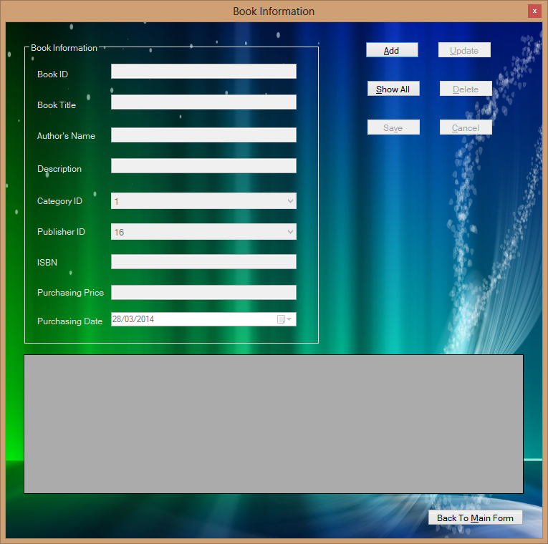

After:

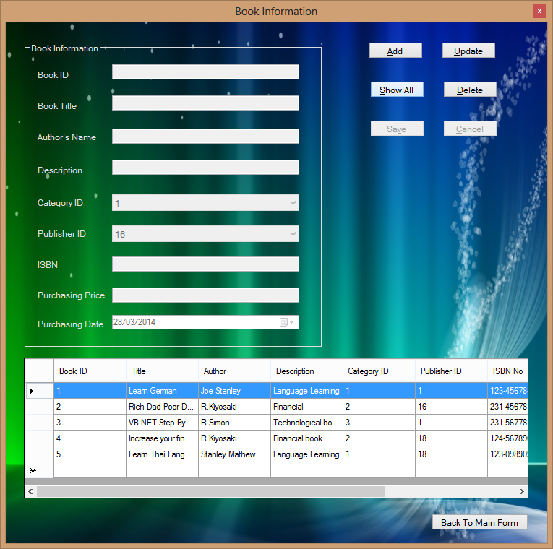

|  |  |
| --- | --- |
| Test Case | 2 |
| Description | To check text boxes cleared and cursor ready for entry pressing “Add” |
| Test Data | Press “Add” button |
| Expected Result | Clear text boxes show “Auto Number” in ID box, and cursor ready for entry |
| Actual Result | As shown below |
| Conclusion | Successful |

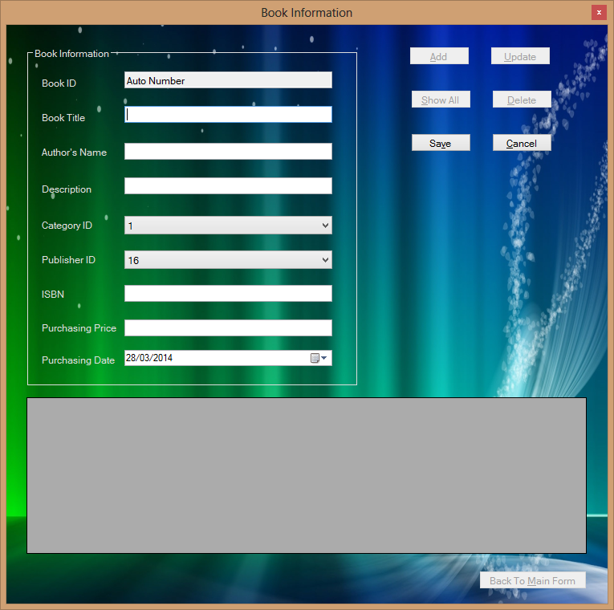

|  |  |
| --- | --- |
| Test Case | 3 |
| Description | To check specific record can be updated pressing “Update” |
| Test Data | Press “Update” button |
| Expected Result | Show selected record’s data in text boxes ready for updating |
| Actual Result | As shown below |
| Conclusion | Successful |

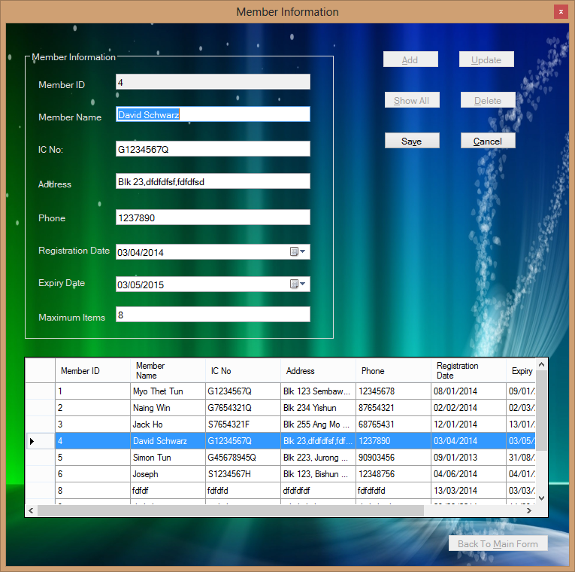

|  |  |
| --- | --- |
| Test Case | 4 |
| Description | To show message of “The record is added.” pressing “Save” to add new record |
| Test Data | Press “Save” button |
| Expected Result | Show message to user that the record has been added when pressing “Save” after typing new data in text boxes |
| Actual Result | As shown below |
| Conclusion | Successful |

Before:

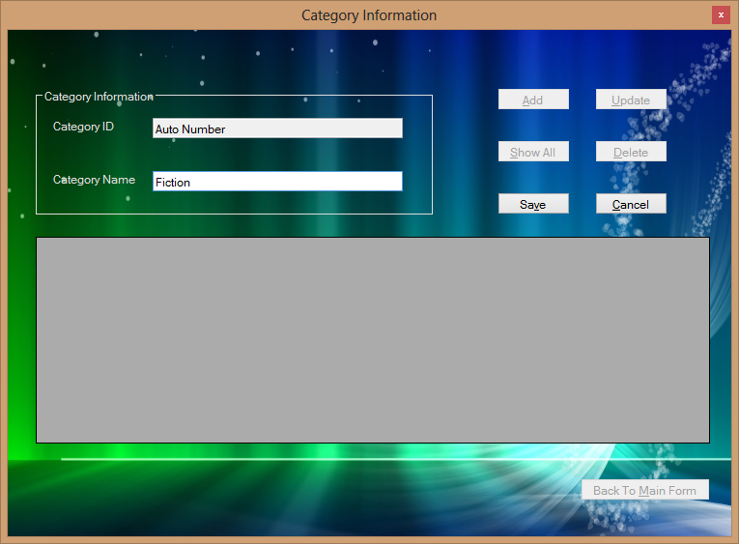

After:

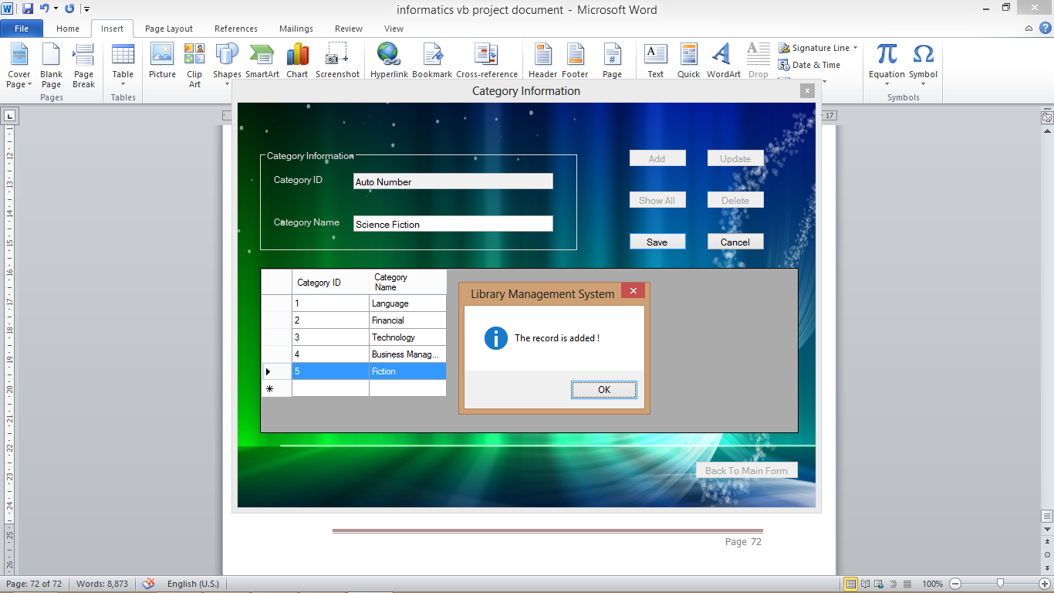

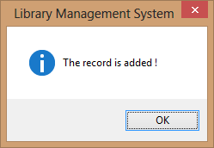

|  |  |
| --- | --- |
| Test Case | 5 |
| Description | To check the new record is added and show in data grid pressing OK |
| Test Data | Press “OK” button in Message Box |
| Expected Result | Show message to user that the record has been added when pressing “Save” after typing new data in text boxes |
| Actual Result | As shown below |
| Conclusion | Successful |

Before:

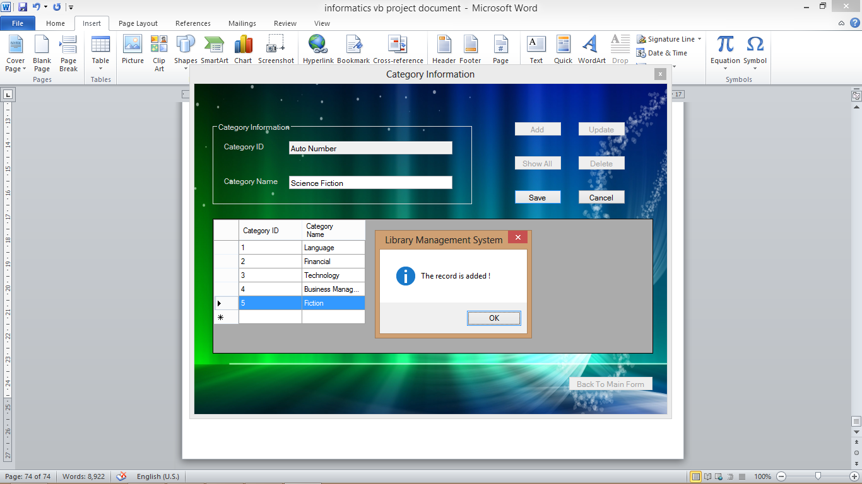



After:

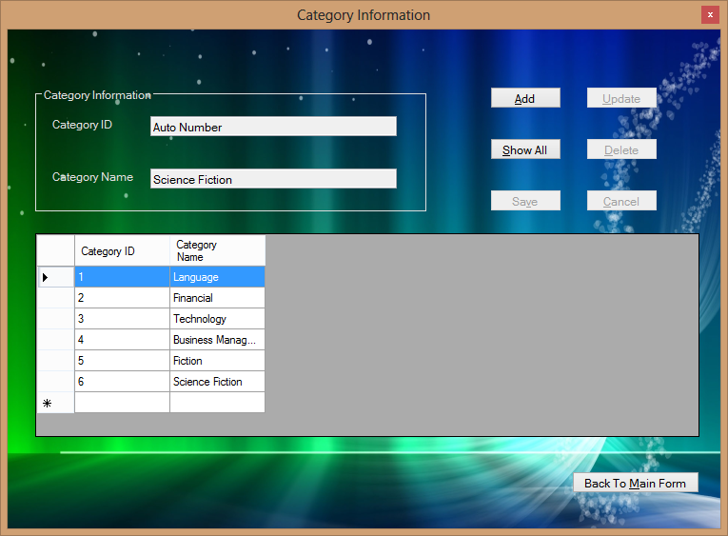

|  |  |
| --- | --- |
| Test Case | 6 |
| Description | To show message of “The record is updated.” pressing “Save” to add update a specific record |
| Test Data | Press “Save” button |
| Expected Result | Show message to user that the specific record has been updated when pressing “Save” after typing updated data in text boxes |
| Actual Result | As shown below |
| Conclusion | Successful |

Before:

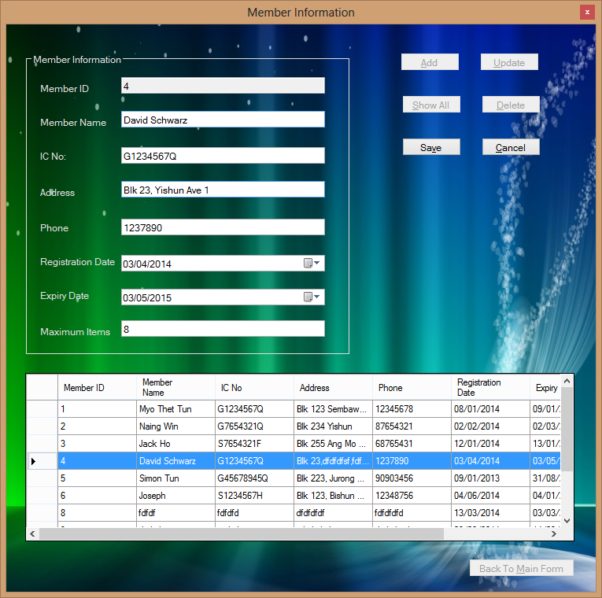

After:

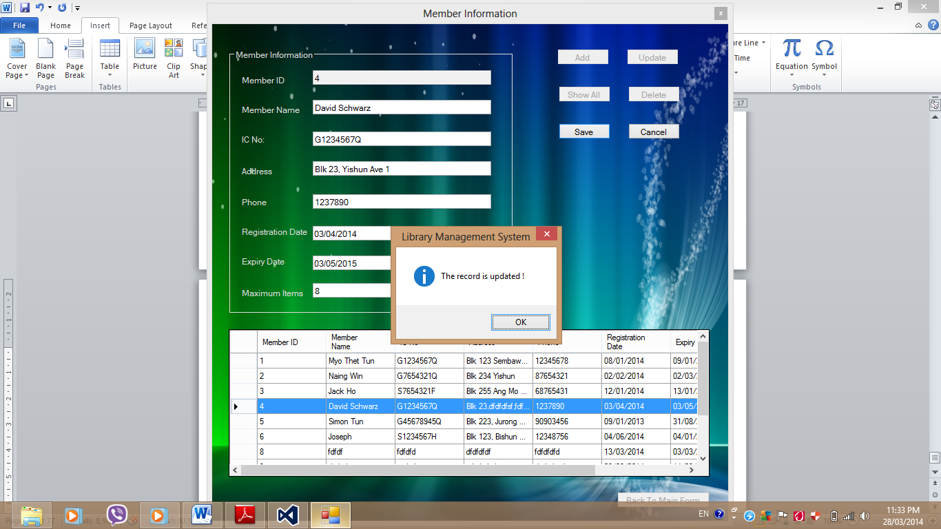

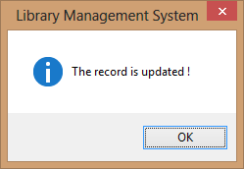

|  |  |
| --- | --- |
| Test Case | 7 |
| Description | To check the specific record is updated and show in data grid pressing OK |
| Test Data | Press “OK” button in Message Box |
| Expected Result | To check the current record is updated and show in data grid pressing OK |
| Actual Result | As shown below |
| Conclusion | Successful |

Before:





After:

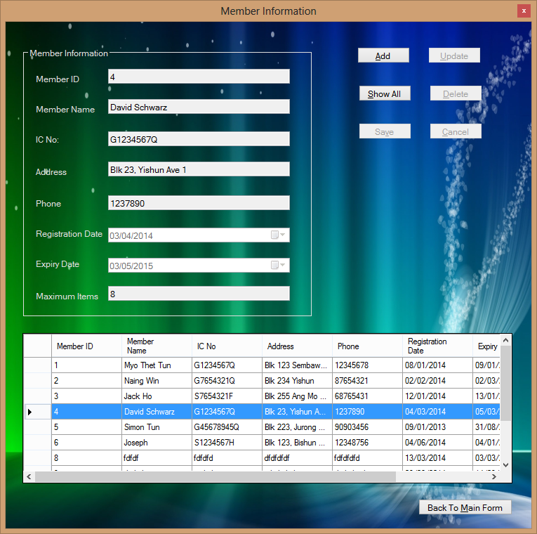

|  |  |
| --- | --- |
| Test Case | 8 |
| Description | To check current action is cancelled and clear text boxes pressing “Cancel” |
| Test Data | Press “Cancel” button |
| Expected Result | To check the current action is cancelled clear text boxes |
| Actual Result | As shown below |
| Conclusion | Successful |

Before:

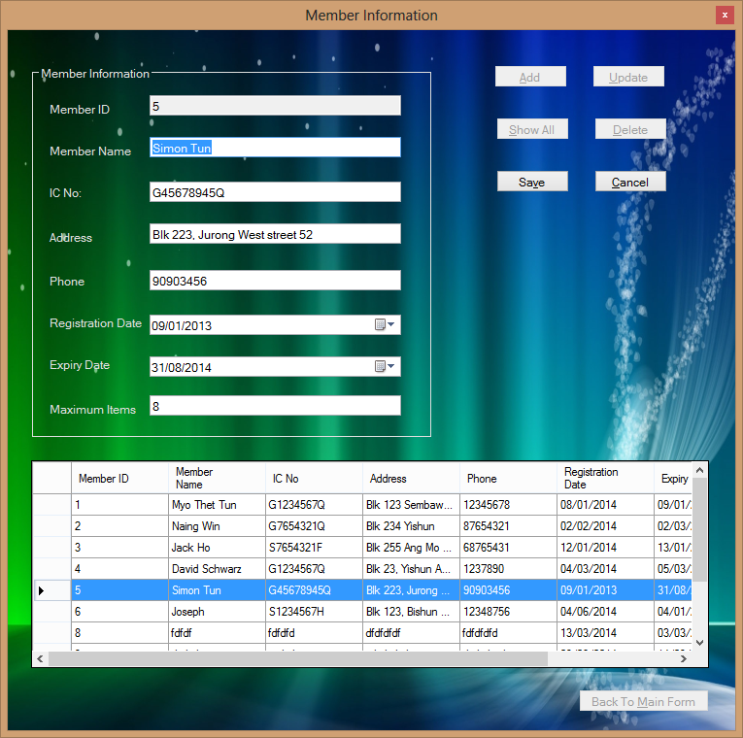

After:

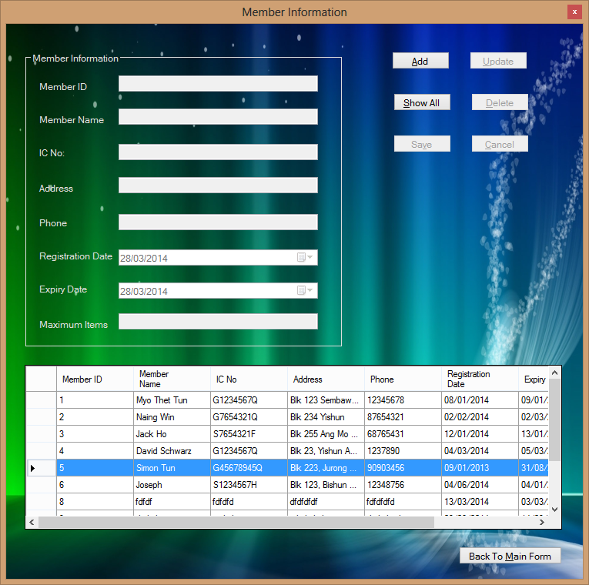

|  |  |
| --- | --- |
| Test Case | 9 |
| Description | To show confirm message to delete a record pressing “Delete” |
| Test Data | Press “Delete” button |
| Expected Result | Show confirm message to user to delete a record |
| Actual Result | As shown below |
| Conclusion | Successful |

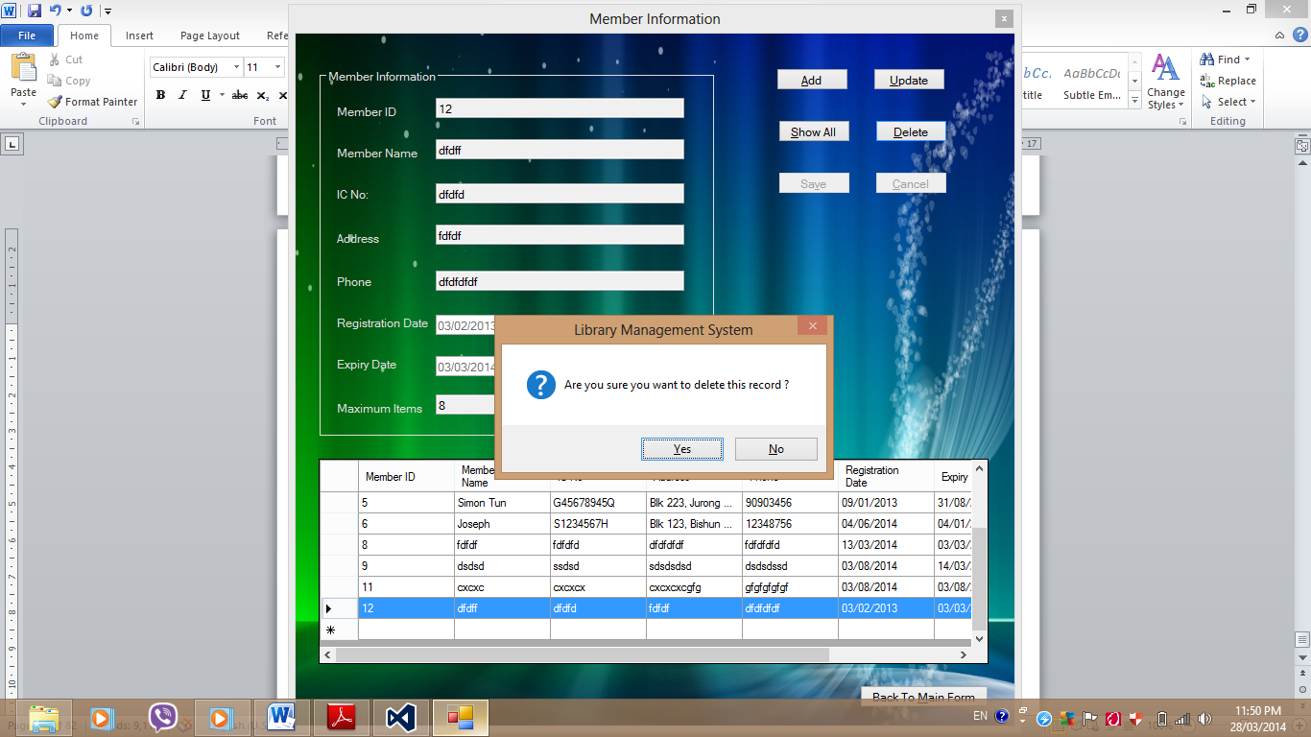

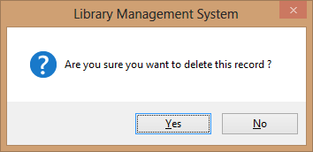

|  |  |
| --- | --- |
| Test Case | 10 |
| Description | To show message that record is not deleted user press “No” on confirm to delete message |
| Test Data | Press “No” button in confirm message box |
| Expected Result | Show “The record is not deleted” message |
| Actual Result | As shown below |
| Conclusion | Successful |

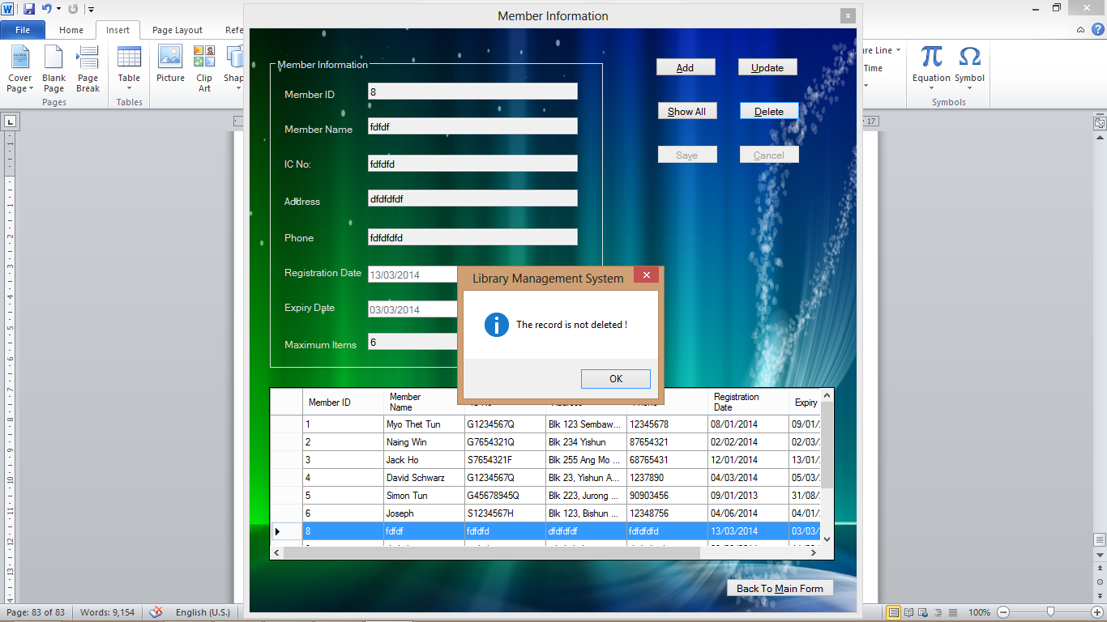

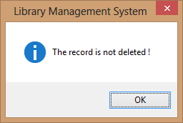

|  |  |
| --- | --- |
| Test Case | 11 |
| Description | To show message that record is deleted user press Yes on confirm to delete |
| Test Data | Press “Yes” button in confirm message box |
| Expected Result | Show “The record is deleted” message |
| Actual Result | As shown below |
| Conclusion | Successful |

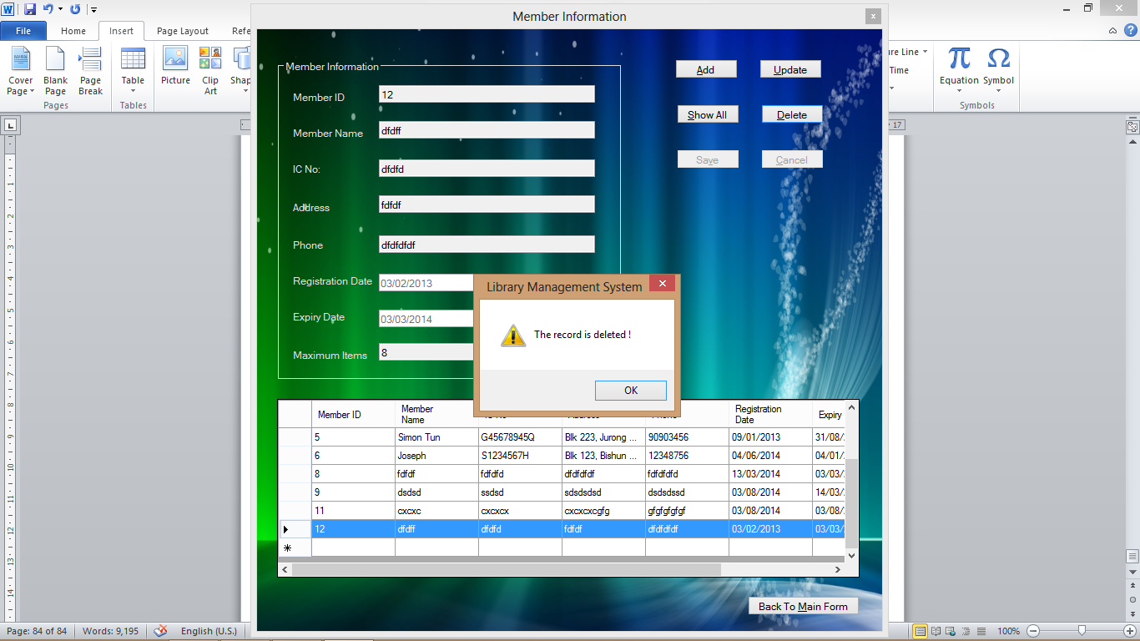

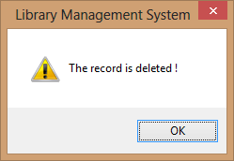

|  |  |
| --- | --- |
| Test Case | 12 |
| Description | To show error message when deleting the blank record in data grid |
| Test Data | Press “Delete” button |
| Expected Result | Show “Error !!! Choose a valid record!” message |
| Actual Result | As shown below |
| Conclusion | Successful |

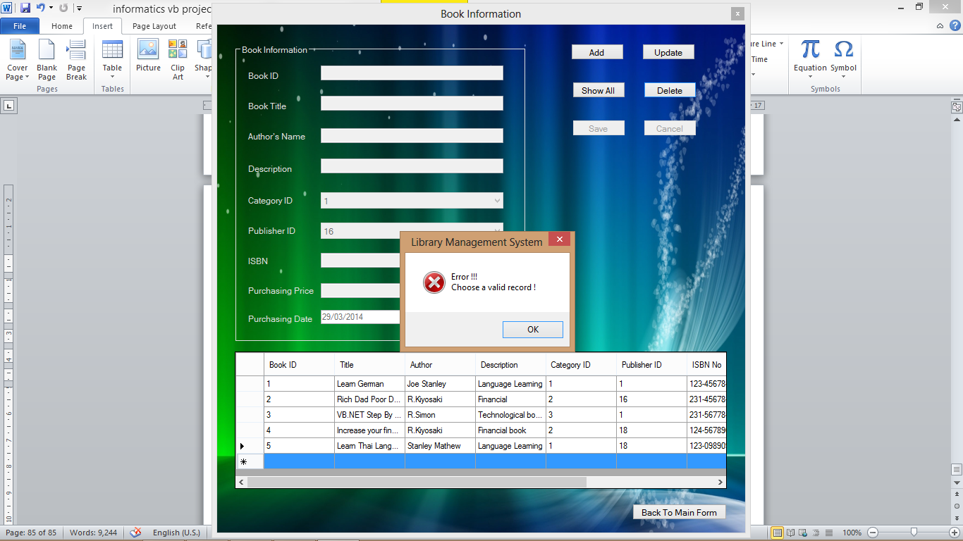

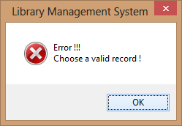

|  |  |
| --- | --- |
| Test Case | 13 |
| Description | To show error message when updating the blank record in data grid |
| Test Data | Press “Update” button |
| Expected Result | Show “Error !!! Choose a valid record!” message |
| Actual Result | As shown below |
| Conclusion | Successful |

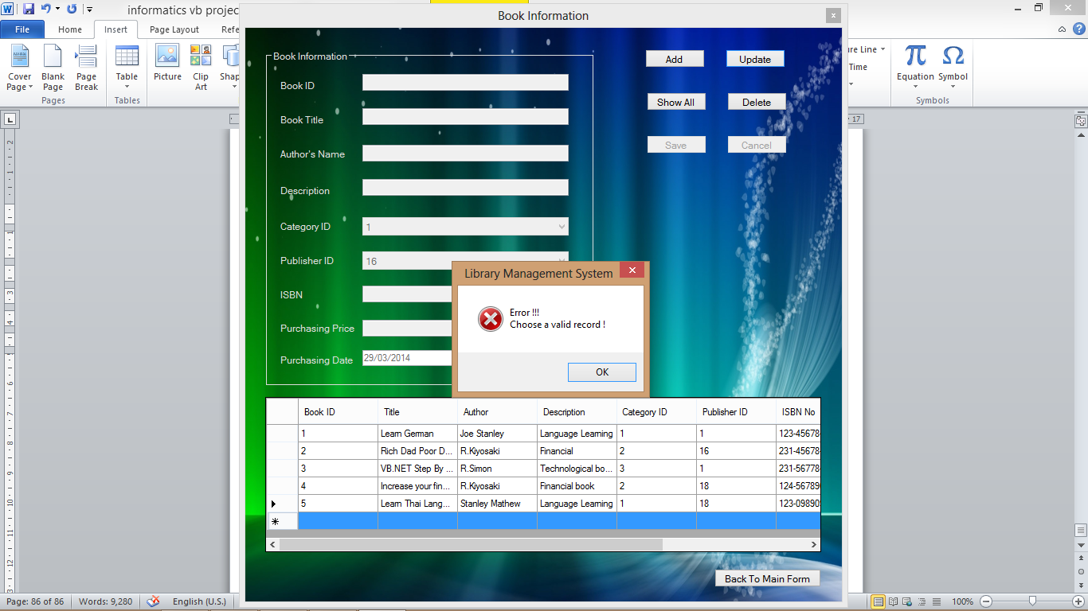

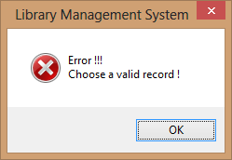

|  |  |
| --- | --- |
| Test Case | 14 |
| Description | To show error message when adding character values to “Maximum Items” field |
| Test Data | Press “Save” button |
| Expected Result | Show “Please enter a valid number !” message |
| Actual Result | As shown below |
| Conclusion | Successful |

Before:

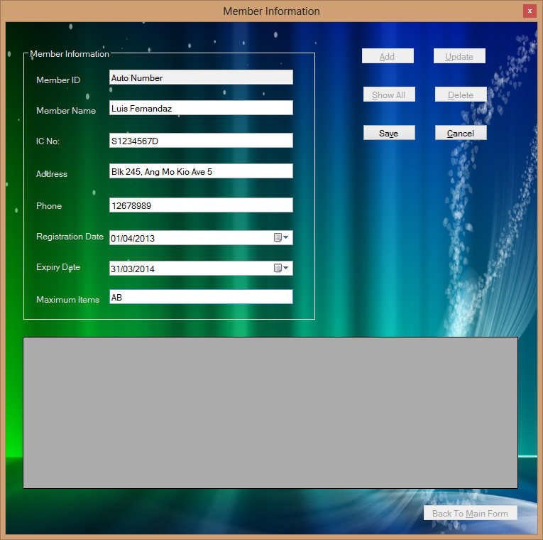

After:

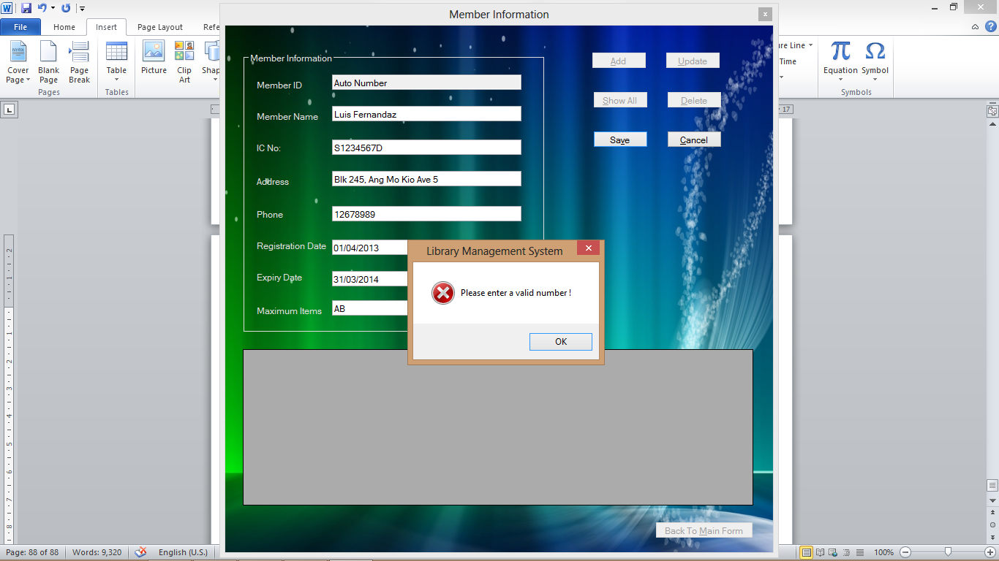

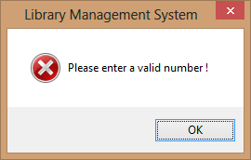

|  |  |
| --- | --- |
| Test Case | 15 |
| Description | To show error message when adding blank field |
| Test Data | Press “Save” button |
| Expected Result | Show “Name cannot be empty !” message |
| Actual Result | As shown below |
| Conclusion | Successful |

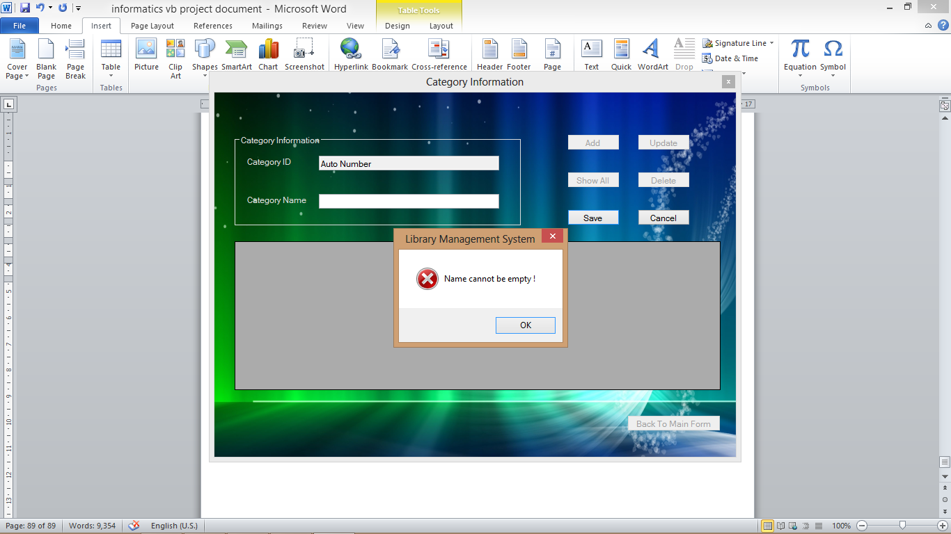

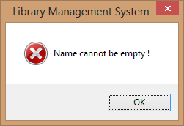

|  |  |
| --- | --- |
| Test Case | 16 |
| Description | To hide current form and show Main when pressing “Back To Main Form” |
| Test Data | Press “Back To Main Form” button |
| Expected Result | Show the main form |
| Actual Result | As shown below |
| Conclusion | Successful |

Before:

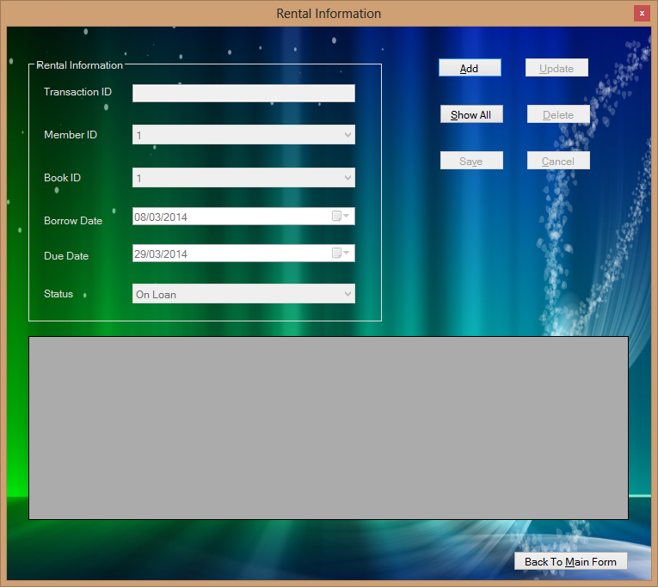

After:



**4.3 test results**

|  |  |
| --- | --- |
| No. | Result |
| 1 | Successful |
| 2 | Successful |
| 3 | Successful |
| 4 | Successful |
| 5 | Successful |
| 6 | Successful |
| 7 | Successful |
| 8 | Successful |
| 9 | Successful |
| 10 | Successful |
| 11 | Successful |
| 12 | Successful |
| 13 | Successful |
| 14 | Successful |
| 15 | Successful |
| 16 | Successful |

1. **OPERATING INSTRUCTION**

**5.1 using the system**

When the user opens the program, the user will see the main page as shown below:



User can choose the form from File menu. File menu includes –

**Member Information** – allows user entry to ‘Member’ page

**Book Information** – allows user entry to ‘Book’ page

**Category Information** – allows user entry to ‘Category’ page

**Publisher Information** – allows user entry to ‘Publisher’ page

**Rental Information** – allows user entry to ‘Rental’ page

**Exit** – allows user to exit from the program

If user chooses ‘Member Information’ form, the member form will come up as shown below.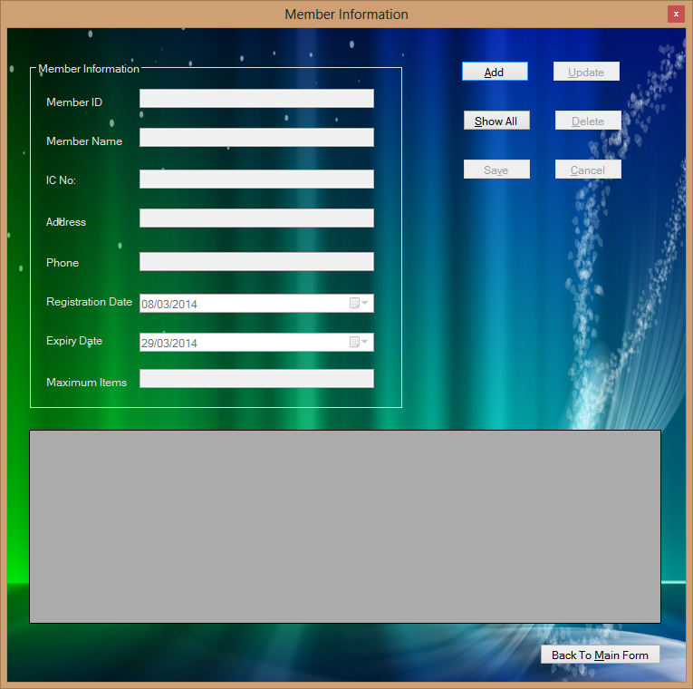

**‘Add’** button allows user to add a new record to the database

**‘Update’** button shows selected record in text boxes and let user to correct the data

**‘Show All’** button allows user to view all records in data grid

**‘Delete’** button allows user to delete the selected record

**‘Save’** button allows user to save the current record to the database

**‘Cancel’** button allows user to cancel the current action and clear the text boxes

**‘Back To Main’** button allows user to go back to the main page

If user chooses ‘Book Information’ form, the book form will come up as shown below.

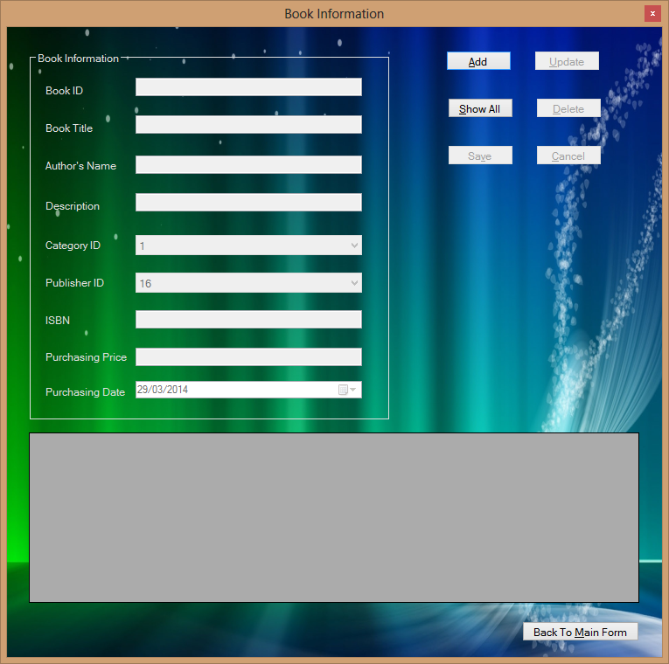

**‘Add’** button allows user to add a new record to the database

**‘Update’** button shows selected record in text boxes and let user to correct the data

**‘Show All’** button allows user to view all records in data grid

**‘Delete’** button allows user to delete the selected record

**‘Save’** button allows user to save the current record to the database

**‘Cancel’** button allows user to cancel the current action and clear the text boxes

**‘Back To Main’** button allows user to go back to the main page

If user chooses ‘Category Information’ form, the category form will come up as shown below.

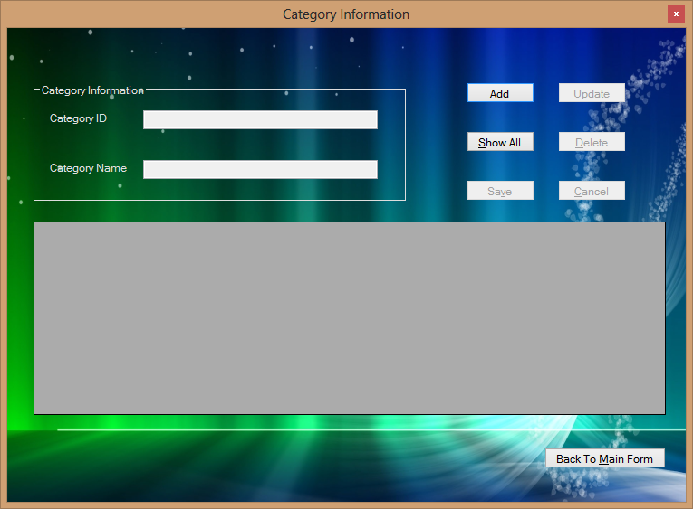

**‘Add’** button allows user to add a new record to the database

**‘Update’** button shows selected record in text boxes and let user to correct the data

**‘Show All’** button allows user to view all records in data grid

**‘Delete’** button allows user to delete the selected record

**‘Save’** button allows user to save the current record to the database

**‘Cancel’** button allows user to cancel the current action and clear the text boxes

**‘Back To Main’** button allows user to go back to the main page

If user chooses ‘Publisher Information’ form, the publisher form will come up as shown below.

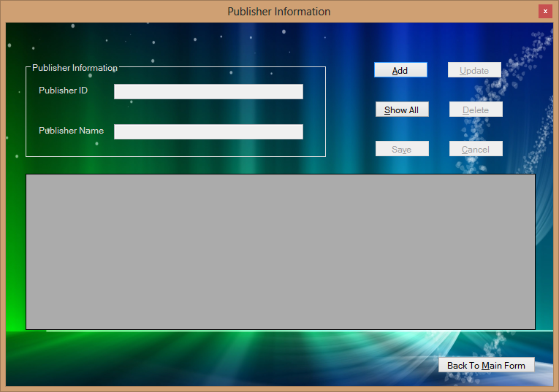

**‘Add’** button allows user to add a new record to the database

**‘Update’** button shows selected record in text boxes and let user to correct the data

**‘Show All’** button allows user to view all records in data grid

**‘Delete’** button allows user to delete the selected record

**‘Save’** button allows user to save the current record to the database

**‘Cancel’** button allows user to cancel the current action and clear the text boxes

**‘Back To Main’** button allows user to go back to the main page

If user chooses ‘Rental Information’ form, the rental form will come up as shown below.



**‘Add’** button allows user to add a new record to the database

**‘Update’** button shows selected record in text boxes and let user to correct the data

**‘Show All’** button allows user to view all records in data grid

**‘Delete’** button allows user to delete the selected record

**‘Save’** button allows user to save the current record to the database

**‘Cancel’** button allows user to cancel the current action and clear the text boxes

**‘Back To Main’** button allows user to go back to the main page

1. **CONCLUSION**

**6.1 program strenghts**

The simple and easy-to-understand user interface allows user able to manage the program without training.

All the database tables are strongly organized and can provide data consistency efficiently.

It is a program that can use without internet connection so it is more stable and more speedy to run.

Every task of this program can perform just as simple as one click so it is very user-friendly.

The colour used in this program is not extremely bright and can provide smooth vision to users.

**6.2 program weaknesses**

Log in page is not included for the system.

Need to press ‘Show All’ button before performing delete or update.

Data validation check is not very strict.

**6.3 program enhancement**

System log in page can be enhanced for better security.

Renewal service can be enhanced.

Reservation service can be included.

Data validation check can be improved.

1. **REFERENCES**

<http://spod.tarc.edu.my/sas/fulltext/201011/ait2/tanchaurchuanait201011f.pdf>

Microsoft Visual Basic 2010 Step by Step – Michael Halvorson

IT 204 Microsoft Visual Basic.net – Informatics Course Book

CNC Automobile project by Lee Yeah Fong (Informatics DIT student 2012)

<http://www.w3schools.com/sql/default.asp>

The Object Oriented Thought Process (3rd Edition) – Matt Weisfeld